NFC

<<Feature>>

(F002070)

|  |  |
| --- | --- |
| Document ID |  |
| Document Owner | **()** |
| Document Version |  |
| Date Issued |  |
| Date Revised | **2020-10-28** |
| GIS1 Item Number |  |
| GIS2 Classification | **Confidential** |

|  |  |  |  |
| --- | --- | --- | --- |
| Document Type | **Feature Implementation Specification (FIS)** | |  |
| Template Version | **6.0b / FFSD 7.1** | |  |
| SysML Report Template Version | **O Beta (9/27/2019)** | |  |
| Document ID | **ffst01.10_featuredocument_sysmlreporttemplate** | |  |
| Document Location |  | |  |
| Document Owner | **Aaron Bonnell-Kangas, Matthew Stockmaster, Aaron DeLong, Farhan Ehsan, Eugene Karpinsky and Juan Tejeda** | |  |
| Document Revision | **FD0** | |  |
| Document Status | **Draft** | |  |
| Date Issued | **2020-10-28** | |  |
| Date Revised | **2020-10-28** | |  |
| Document Classification | GIS1 Item Number: | **27.60/35** |  |
| GIS2 Classification: | **Confidential** |

|  |  |  |  |
| --- | --- | --- | --- |
| Document Approval | | | |
| Person | Role | Email | Date |
|  |  |  |  |
|  |  |  |  |
|  |  |  |  |

PRINTED COPIES ARE UNCONTROLLED

**Disclaimer**

**This document contains Ford Motor Company Confidential information. Disclosure of the information contained in any portion of this document is not permitted without the expressed, written consent of a duly authorized representative of Ford Motor Company, Dearborn, Michigan, U.S.A.**

This document contains information developed and accumulated by and for FORD MOTOR COMPANY. As such, it is a proprietary document, which, if disseminated to unauthorized persons, would provide others with restricted information, data, or procedures not otherwise available, exposing the FORD MOTOR COMPANY to potential harm.

Employees and suppliers having custody of this specification or authorized to use it must be cognizant of its proprietary nature and ensure that the information herein is not made available to unauthorized persons.

FORD MOTOR COMPANY reserves the right to protect this work as an unpublished copyrighted work in the event of an inadvertent or deliberate unauthorized publication. FORD MOTOR COMPANY also reserves its rights under copyright laws to protect this work as a published work.

This document or portions thereof shall not be distributed outside FORD MOTOR COMPANY without prior written consent. Refer all questions concerning disclosure to the author(s) or any duly authorized representative of Ford Motor Company.

**Copyright** © **2019 Ford Motor Company**

**Contents**

1 Introduction 6

1.1 Document Purpose 6

1.2 Document Scope 6

1.3 Document Audience 6

1.3.1 Stakeholder List 6

1.4 Document Organization 6

1.4.1 Document Context 6

1.4.2 Document Structure 6

1.5 Document Conventions 7

1.5.1 Requirements Templates 7

1.5.1.1 Identification of requirements 7

1.5.1.2 Requirement Attributes 7

2 Feature Implementation Overview 8

2.1 Description 8

2.2 Input Requirements 8

2.3 Assumptions 9

2.4 References 9

2.4.1 Ford Documents 9

2.4.2 External Documents and Publications 10

2.5 Glossary 10

2.5.1 Definitions 10

2.5.2 Abbreviations 11

3 Feature Implementation Architecture 12

3.1 Functional Architecture 12

3.1.1 Description 12

3.1.2 Function List 12

3.1.2.1 Functions of 13

3.1.2.2 Functions of 14

3.1.3 Signal List 14

3.2 Physical Architecture 18

3.2.1 E/E Architecture 18

3.2.1.1 E/E Architecture Variants 19

3.2.1.2 E/E Components 20

3.2.1.3 E/E Connections 20

3.2.1.4 Signal List 22

3.2.2 Software Component Architecture 22

3.2.2.1 Description 22

3.3 Function Deployment 22

3.3.1 Deployment Variants 23

3.3.1.1 Main (Only) variant 23

3.3.1.2 Deployment “Variant 1” 23

3.3.2 Function Allocation 24

3.3.2.1 Functional Safety 25

4 Feature Implementation Modeling 27

4.1 Component Interaction Diagrams 27

4.1.1 Scenario: “System Startup / Shutdown” 27

4.1.2 Scenario: “Normal Operation” 27

4.1.3 Functional Safety 28

4.1.3.1 Fault Handling Time Analysis 28

4.1.3.2 Requirements Derivation Diagram 29

4.2 Component Interface Behavior Diagrams 29

5 Feature Implementation Requirements 30

6 Open Concerns 31

7 Revision History 32

8 Appendix 33

8.1 Data Dictionary 33

8.1.1 Logical Signals 33

8.1.2 Logical Parameters 33

8.1.3 Technical Signals 33

8.1.3.1 GSDB Signals 34

8.1.3.2 Service Oriented Communication 34

8.1.3.3 Hardwired Signals 34

8.1.3.4 Diagnostic Interfaces 34

8.1.4 Technical Parameters 36

8.1.5 Mappings 36

8.1.6 Technical Interfaces 37

8.1.6.1 AIS Interfaces 37

8.1.6.2 Service Oriented Communcation (SoC) Interfaces 38

8.1.6.3 AUTOSAR Ports (SW Interfaces) 38

8.1.7 Messages 38

8.1.7.1 CAN Bus “<Bus Name>” 38

8.1.7.2 LIN Bus “<Bus Name>” 39

8.1.8 Encoding Types 39

**List of Figures**

Figure 1: 21

Figure 2:  24

Figure 3: 30

**List of Tables**

Table 1‑1: Electrical Architecture(s) referenced in this document 6

Table 1‑2: Functions referenced in this document 6

Table 2‑1: Ford Internal Documents 10

Table 2‑2: Ford Internal Documents *(not specified in SysML model)* 11

Table 2‑3: External Documents and Publications 11

Table 2‑4: External Documents and Publications *(not specified in SysML model)* 11

Table 2‑5: Definitions Used In This Document 12

Table 2‑6: Abbreviations used in this document 12

Table 3‑1: List of Functions 15

Table 3‑2: List of ‑‑ Functions 15

Table 3‑3 List of signals sent by 18

Table 3‑4 List of signals received by 19

Table 3‑5: Electrical Components 21

Table 3‑6: E/E Connections for 23

Table 3‑7: Function Allocation Table 26

Table 3‑8: Function Allocation Table 27

Table 3‑9: Architectural Redundancy Summary 27

Table 4‑1: Fault Handling Time Table 30

Table 5‑1: Input Signal mappings of ‑ 34

Table 5‑2: Output Signal mappings of ‑ 35

Table 5‑3: Parameter mappings of ‑ 36

Table 5‑4: Component Specific Requirements 37

Table 5‑5: Inherited Requirements 37

Table 5‑6: Input Signal mappings of ‑ 39

Table 5‑7: Output Signal mappings of ‑ 40

Table 5‑8: Parameter mappings of ‑ 40

Table 5‑9: Component Specific Requirements 40

Table 5‑10: Inherited Requirements 40

Table 5‑11: Input Signal mappings of Component: ‑ 41

Table 5‑12: Output Signal mappings of Component: ‑ 42

# Introduction

## Document Purpose

The Feature Implementation Specification (FIS) specifies the deployment of the functions of a feature to an electrical architecture. The FIS specifies all interactions between the ECUs of the electrical architecture required for the feature including the technical signals and the interfaces. It also gives interface and integration requirements, which are specific to the feature for the electrical architecture.

To get more information about the concept of feature, function and component level abstraction refer to the [Ford RE Wiki](http://wiki.ford.com/display/RequirementsEngineering/Requirements+Engineering+for+SW+Enabled+Features).

## Document Scope

This FIS describes the deployment of the feature <Feature> to the following electrical architecture(s):

| **Electrical Architecture Name** | **Owner** | **Reference** |
| --- | --- | --- |
| e.g. CGEA1.3 |  |  |
|  |  |  |

Table 2‑1: Electrical Architecture(s) referenced in this document

The following functions from the [Global Feature & Function List](https://www.vsemweb.ford.com:443/tc/launchapp?-attach=true&-s=226TCSession&-o=ZmZNi0JHx3NrTDAAAAAAAAAAAAA) are referenced in this Feature Implementation Specification:

|  |  |  |  |
| --- | --- | --- | --- |
| **Feature ID** | **Feature Name** | **Owner** | **Reference** |
| F002070 | NFC  (Program(s): P708 MY23) | Aaron Bonnell-Kangas, Matthew Stockmaster, Aaron DeLong, Farhan Ehsan, Eugene Karpinsky and Juan Tejeda |  |

| **Function ID** | **Function (Group) Name** | **Owner** | **Reference** |
| --- | --- | --- | --- |
|  |  |  |  |
|  |  |  |  |

Table 2‑2: Functions referenced in this document

## Document Audience

The FIS is authored by - . All Stakeholders, i.e., all people who have a valid interest in the feature implementation should read and, if possible, review the FIS. It needs to be guaranteed, that all stakeholders have access to the currently valid version of the FIS.

### Stakeholder List

For the latest list of the function stakeholders and their roles & responsibilities refer to <Put VSEM Link here>.

|  |  |  |  |  |
| --- | --- | --- | --- | --- |
| **Name** | **CDSID** | **Contact Info** | **Role** | **Stakeholder Group** |

## Document Organization

### Document Context

Refer to the [Specification Structure page](http://wiki.ford.com/display/RequirementsEngineering/Specification+templates) in the [Ford RE Wiki](http://wiki.ford.com/display/RequirementsEngineering/Requirements+Engineering+for+SW+Enabled+Features) to understand how the FIS relates to other Ford Requirements Documents and Specifications.

### Document Structure

**Section 1** Introduction – Giving an explanation how to use this document including responsibilities and the scope of the document. Additionally it contains the revision history and a list of unsettled but known issues that have to be consolidated in future versions. It explains the terminology and gives a clarification of the definitions, concepts and abbreviations used in the document.

**Section 2** Feature Implementation Description – Giving an overview of the platform and listing assumptions, constraints or dependencies

**Section 3** Feature Implementation Architecture – Describing 3 Architecture Views:

* Functional Architecture – Showing the logical architecture of functions
* Physical Architecture – Showing the physical architecture (first of all the E/E Architecture), which the Logical Functions get allocated to.
* Function Deployment – Presenting the allocation of logical functions and signals to the electrical and other components

**Section 4** Deployment Specific Modeling –Modeling techniques providing additional detail on e.g. interface behavior

**Section 5** Deployment Specific Requirements – Deployment specific requirements for ECUs, Network Communication, and Process

**Section 6** List of Open Concerns

**Section 7** Revision History

**Section 8** Appendix - Presenting additional data mainly in a tabular form, e.g., a data dictionary

## Document Conventions

### Requirements Templates

Each requirement in this specification shall follow the corresponding template given in the document template *Specification_Macros.dotm* on Wiki page [“Specification Templates”](http://wiki.ford.com/display/RequirementsEngineering/Specification+templates?src=contextnavpagetreemode). This document template also provides macros to insert the requirement templates. Refer to “[How to use the Specification Templates](http://wiki.ford.com/display/RequirementsEngineering/How+to+use+the+Specification+Templates?src=contextnavpagetreemode)” on how to enable the macros and the requirements templates in this specification.

The requirements macro and requirements templates also enable the import of the specification to VSEM (refer to ["How to import specifications into VSEM as separate requirements"](http://wiki.ford.com/pages/viewpage.action?pageId=104991616&src=contextnavpagetreemode)).

#### Identification of requirements

The unique requirement ID given in the headline of any requirement follows the requirement throughout the development process. The requirement ID format follows a well-defined syntax.

All identifiers in an FIS shall be composed of 4 parts:

* A leading prefix, which indicates the type of requirement (R=Requirement, UC=Use Case, SC=Scenario, …)
* A prefix, which indicates the abstraction level (F=Feature, FNC=Function, CMP = component).
* Followed by a name, indicating the scope, which the requirement belongs to (e.g. feature or function name )
* Ending with the actual requirement number

*Example:*

*R_CMP_LockArbitrator_00004* This is the fourth requirement on component level for the function Lock Arbitrator.

#### Requirement Attributes

Attributes may be added to each requirement. This helps to classify the requirements. A [list of available attributes](http://wiki.ford.com/display/RequirementsEngineering/Requirements+Attributes?src=contextnavpagetreemode) is given in the Requirements Engineering Wiki.

# Feature Implementation Overview

## Description

F002070 NFC

NFC Entry & Starting enables a customer to unlock and start their vehicle using an NFC-enabled device (e.g. key card or smartphone) as a vehicle key. To unlock the vehicle, the customer holds their NFC-enabled device near an exterior NFC reader of the vehicle. To authorize start and drive-away, the customer holds their NFC-enabled device near, or places it on, an interior NFC reader of the vehicle.

## Input Requirements

*See the Feature Document for relevant input requirements*

### Legal Requirements

* : ECE-116 Vehicle Alarm and Immobilizer
* : Legal & Insurance Requirements
* : USA/CAN NHTSA Driver Distraction Guidelines
* : USA/CDN F/CMVSS 114 Theft Protection and Rollaway Prevention

### Trustmark Requirements

* : Controls/Features Layout & Behavior
* : Identification of Security Functions - Cyber Security
* : Key Device Programming Instructions
* : Key In Reminder Chime
* : Labeling Methods and Types
* : Logic of Operation: Feedback
* : Logic of Operation: Interpretation
* : Logic of Operation: Interruptibility
* : Logic of Operation: Not Intended For Use While Driving
* : Logic of Operation: Use of Systems with Visual Displays
* : Logic of Operation: Visual Information
* : Operational Stereotypes
* : Secure Idle Control Function
* : Symbols Usage and Legibility
* : Usability of In-Vehicle Systems / Components

### Industry Standards

* ISO / IEC 14443 : Contactless Proximity Technology
  + Standard for contactless proximity technology.
  + Subset of RFID, limited to 13.56 MHz frequency
  + Active action required
  + Short range (several cm)
* : P2P and Card Emulation Modes
* : Smartphone as a Key Technology
* : Standard for Functional Safety

## Lessons Learned

1. NFC readers should be packaged close enough to an A-surface to allow for a 5-10cm read range from that A-surface.
2. NFC readers should be packaged at least 20mm away from sheet metal or other similar interfering materials.
3. NFC Logo should withstand recurring contact from NFC Device, as this will happen a lot
4. NFC Card dimensions should match the NFC Reader dimensions for best read performance.
5. NFC Logo should be on readers to indicate to the user where to scan

## Assumptions

No Assumptions specified.

## References

### Ford Documents

List here all Ford internal documents, which are directly related to the feature.

| **Reference** | **Title** | **Doc. ID** | **Document Location** | **Revision** |
| --- | --- | --- | --- | --- |
|  |  |  |  |  |

Table 4: Ford internal Documents *(not specified in SysML model)*

### Ford Documents

| **Reference** | **Title** | **Doc. ID** | **Revision** |
| --- | --- | --- | --- |
|  |  |  |  |

Table 3‑6: Ford Internal Documents *(not specified in SysML model)*

### External Documents and Publications

The list of external documents could include books, reports and online sources.

| **Reference** | **Document / Publication** |
| --- | --- |
|  |  |

Table 3‑8: External Documents and Publications *(not specified in SysML model)*

## Glossary

### Definitions

*No glossary items found.*

### Abbreviations

*No acronyms specified.*

# Feature Implementation Architecture

## Functional Architecture

### List of Functions

### Description

The information contained herein is similar to that in the Feature Document and Functional Specification and shows the activity diagrams which define the top-level (and lower level as necessary) function of the feature. Each shown diagram contains a function which is allocated to one of the logical systems of the feature or is a parent/ancestor function to one a function which is allocated thereto. Diagrams are presented in a depth-first format. That is, after a diagram is presented, any sub-diagrams of it are presented before proceeding to the next sibling diagram (or the next diagram in the list).

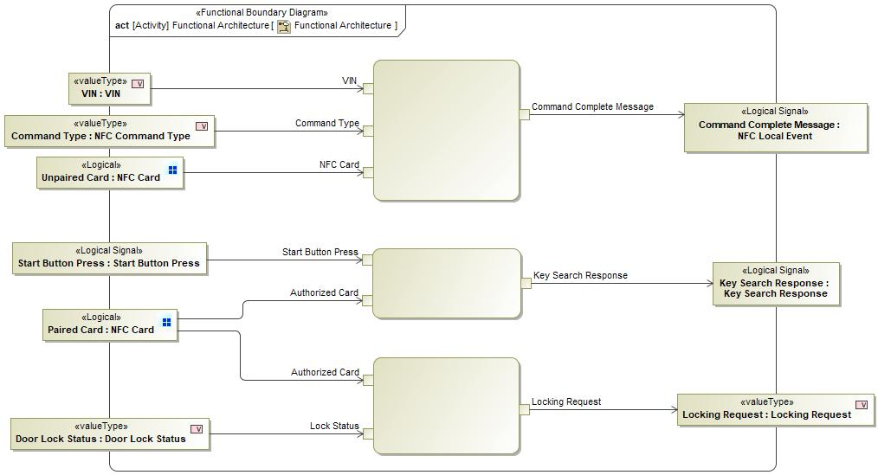

**Figure 1:** **Functional Architecture**

### Function List

| **Function ID** | **Function Name** | **Function Description** |
| --- | --- | --- |
| *No ID specified* |  | *No documentation provided* |
| *No ID specified* |  | *No documentation provided* |
| *No ID specified* |  | *No documentation provided* |

### Signal List

|  |  |  |
| --- | --- | --- |
| **Signal Name** | **Description** | **Details** |
| **MyKey_Created** |  |  |
| **RemoteStartStatus** |  |  |
| **Cancel** |  |  |
| **Un-fleetify** |  |  |
| **Vehicle starts** |  |  |
| **Mobile App Approval Response** |  |  |
| **Signal Validity** |  |  |
| **CardPairingRecords** |  |  |
| **Delete_Retail_Secondary_digital_Key** |  |  |
| **NFC_Device_removed** |  |  |
| **Cancel** |  |  |
| **User selects "Yes" - replace existing device** |  |  |
| **WaitingForNewNfcMyKey** |  |  |
| **StartingAuthorized** |  |  |
| **Vehicle_Locked** |  |  |
| **Subscribe to NFC management feature** |  |  |
| **Navigate to Unified Key Management Screen** |  |  |
| **Remove NFC Key Process terminated** |  |  |
| **User selects "Yes" - overwrite existing link** |  |  |
| **MyKey NFC Addition Screen** |  |  |
| **NFC_Enabled** |  |  |
| **Command Delivered** |  |  |
| **ECUProv_Alert** |  |  |
| **Digital_Key_activated** |  |  |
| **User_requests_activate_user connectivity** |  |  |
| **Start button pressed** |  |  |
| **Off** |  |  |
| **LastAuthorizedKey** |  |  |
| **Vehicle_Selected_in_App** |  |  |
| **State Ack** |  |  |
| **Trigger Deauthorization** |  |  |
| **Failed PK search** |  |  |
| **OK** |  |  |
| **DoorLockState** |  |  |
| **NFC_Fleet_Disabled** |  |  |
| **IgnitionStatus** |  |  |
| **Name_Digital_Key** |  |  |
| **Delete** |  |  |
| **NFC Command Complete Event** |  |  |
| **Navigate to Vehicle Settings Menu** |  |  |
| **Create MyKey NFC Device** |  |  |
| **NFC_programming mode** |  |  |
| **Cancel** |  |  |
| **OK** |  |  |
| **Technician_queries_NFC** |  |  |
| **Password_introduced** |  |  |
| **SecureIdleStatus** |  |  |
| **Fleetify** |  |  |
| **OK** |  |  |
| **Vehicle_Unlocked** |  |  |
| **Retail User Approval Status** |  |  |
| **Press "Add a Key"** |  |  |
| **NFC_Disabled** |  |  |
| **VIN** |  |  |
| **Personal Profiles Process terminated** |  |  |
| **NfcCloudEvent** |  |  |
| **On** |  |  |
| **Navigate to Sync Settings Menu** |  |  |
| **ECUProv_Alert1** |  |  |
| **OK** |  |  |
| **User_Start_Vehicle** |  |  |
| **Remove NFC Key Request** |  |  |
| **Make a new MyKey** |  |  |
| **Clear_MyKeys** |  |  |
| **Navigate to NFC Card Info Screen** |  |  |
| **Driver Information Message** |  |  |
| **User_Retail_Admin** |  |  |
| **AdditionalKeyStorageAvailable** |  |  |
| **Add NFC Key Process terminated** |  |  |
| **Match Status** |  |  |
| **Share_Digital_Key** |  |  |
| **Personal Profiles Addition/Modification Screen** |  |  |
| **Add NFC Key Request** |  |  |
| **StartingKeyType** |  |  |
| **PendingRequests** |  |  |
| **NfcRetailCommandRequest** |  |  |
| **Vehicle enters motive state** |  |  |
| **User_Accepts_Prompt** |  |  |
| **NFC_Fleet_Enabled** |  |  |
| **NfcCardCommand** |  |  |
| **Link To This Profile Instead** |  |  |
| **Retail_Secondary_User_For_this_vehicle** |  |  |
| **NFAMProvisioningAlert** |  |  |
| **Replace Existing Device** |  |  |
| **User skips pairing** |  |  |
| **No reply from BCM** |  |  |
| **Digital_Key_Deactivated** |  |  |
| **Delete_Own_Digital_Key** |  |  |
| **service tool cloud event** |  |  |
| **BCM is ready** |  |  |
| **PK Search Failed** |  |  |
| **Create_MyKey** |  |  |
| **Enable_NFC_Request** |  |  |
| **User selects** |  |  |
| **ACK** |  |  |
| **Unsubscribe from NFC management feature** |  |  |
| **test** |  |  |
| **User chickens out** |  |  |
| **Connectivity_Deactivated** |  |  |
| **activate_digital_key** |  |  |
| **Disable_NFC_Request** |  |  |
| **NFC MyKey - Creation Status** |  |  |
| **MyKey NFC Addition Process Terminated** |  |  |
| **NFC device** |  |  |

**Signals sent by**

| Signal Name | Generating Function | Target |
| --- | --- | --- |

Table 4‑15 List of signals sent by

**Signals received by**

| Signal Name | Receiving Function | Source |
| --- | --- | --- |

Table 4‑4 List of signals sent by

## Physical Architecture

### E/E Architecture

#### E/E Architecture Variants

|  |  |  |
| --- | --- | --- |
| E/E Architecture Variant Name | Variant Description | Variant Condition (optional) |
| “FNV2” | Only variant requires FNv2 |  |

##### E/E Architecture: Physical Architecture

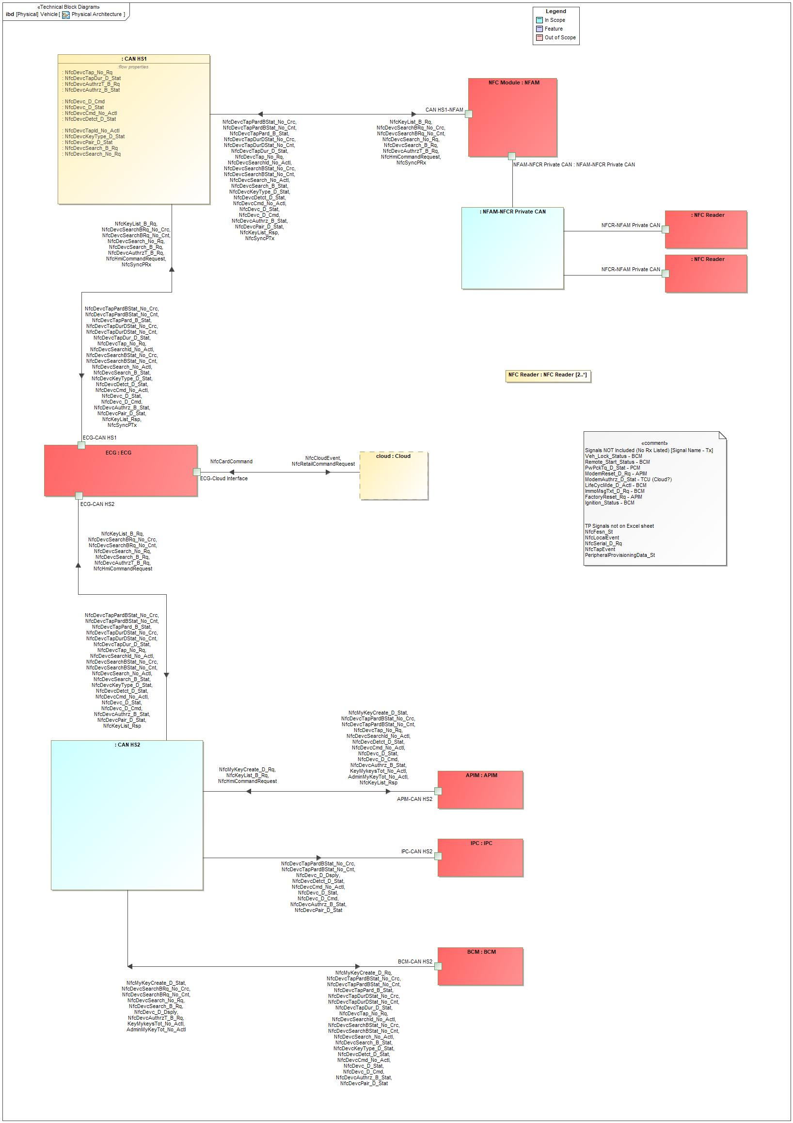

Figure 2: Physical Architecture

#### E/E Components

| **Component Name** | **Description** |
| --- | --- |

Table 4‑16: Electrical Components

#### E/E Connections

#### Signal List

### Software Component Architecture

#### Description

## Function Deployment

### Deployment Variants

|  |  |  |
| --- | --- | --- |
| **Deployment Variant Name** | Variant Description | Variant Condition (optional) |
| Conventional Variant |  |  |

### Function Allocation

| **Function ID** | **Logical Function Name** | **Component Name** | |
| --- | --- | --- | --- |
| **Software** | **Hardware** |

Table 4‑18: Function Allocation Table

#### Functional Safety

| Component/ Interface | Overall Component ASIL | Functional Requirements | | | Component Requirements | |
| --- | --- | --- | --- | --- | --- | --- |
| Function Name | Requirement | Req. ASIL | Requirement | ASIL |

Table 4‑20: Function Allocation Table

|  |  |  |  |  |
| --- | --- | --- | --- | --- |
| **Affected Components/**  **Subsystems/ Data** | **Redundant Component/ Subsystem/ Data** | **If redundancy is used:** | | |
| **Rational for why the redundant component is needed/ suitable** | **Reference to Safety Analysis** | **Requirements Calling for redundancy (Reference to Req IDs)** |

Table 4‑21: Architectural Redundancy Summary

# Feature Implementation Modeling

## Component Interaction Diagrams

### Scenario: “Exit Secure Idle with an NFC Key”

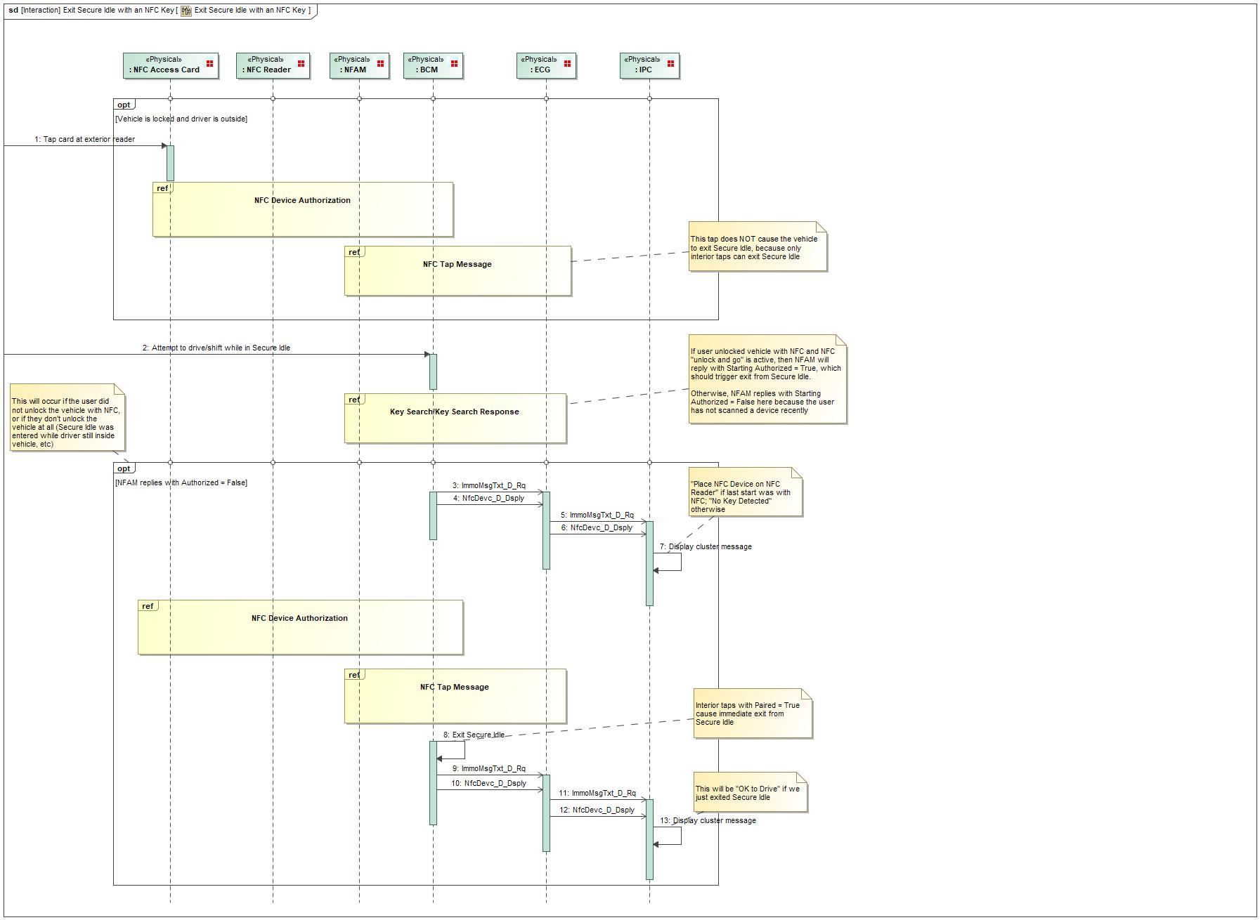

Figure 4: Exit Secure Idle with an NFC Key

### Scenario: “Locking or unlocking a vehicle from exterior”

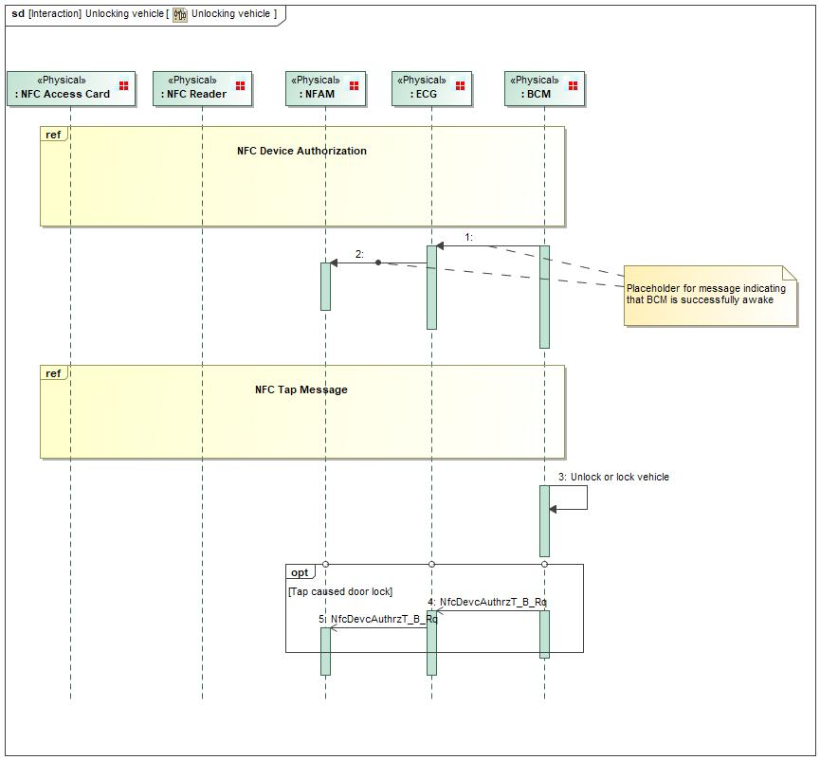

Figure 4: Unlocking vehicle

### Scenario: “Place MyKey restrictions on NFC key (retail)”

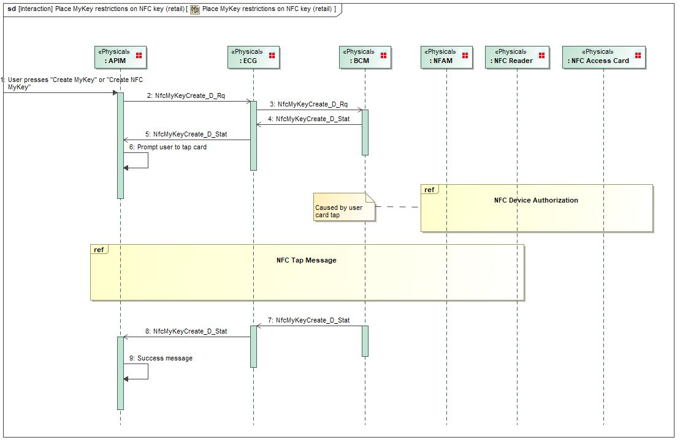

Figure 4: Place MyKey restrictions on NFC key (retail)

### Scenario: “Starting a vehicle with interior NFC authorization”

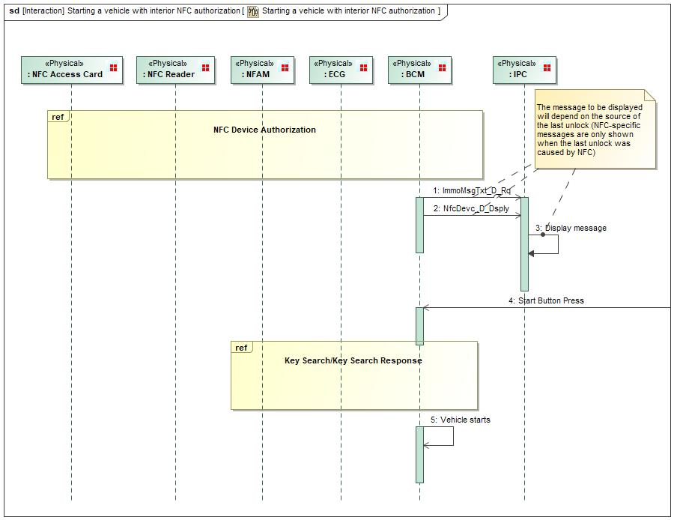

Figure 4: Starting a vehicle with interior NFC authorization

### Scenario: “Remove an NFC key card (Retail)”

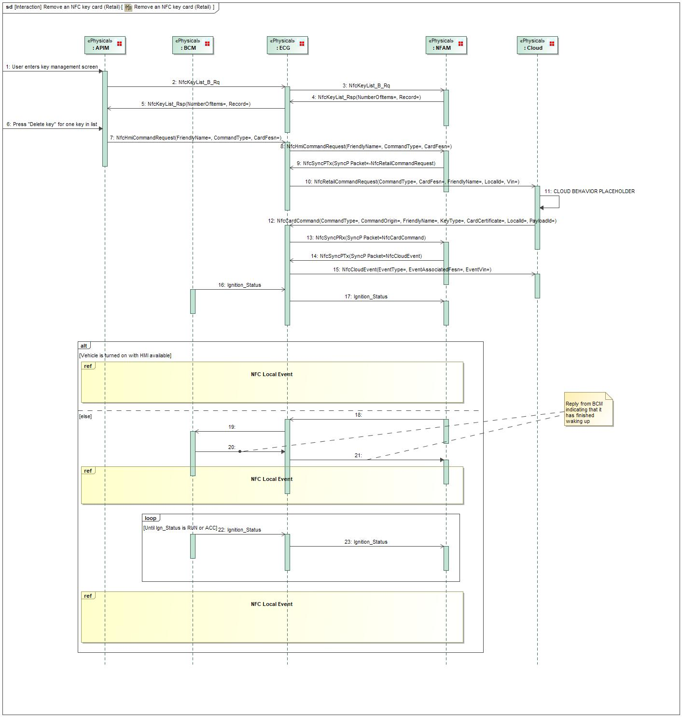

Figure 4: Remove an NFC key card (Retail)

### Scenario: “Starting a vehicle with exterior NFC authorization”

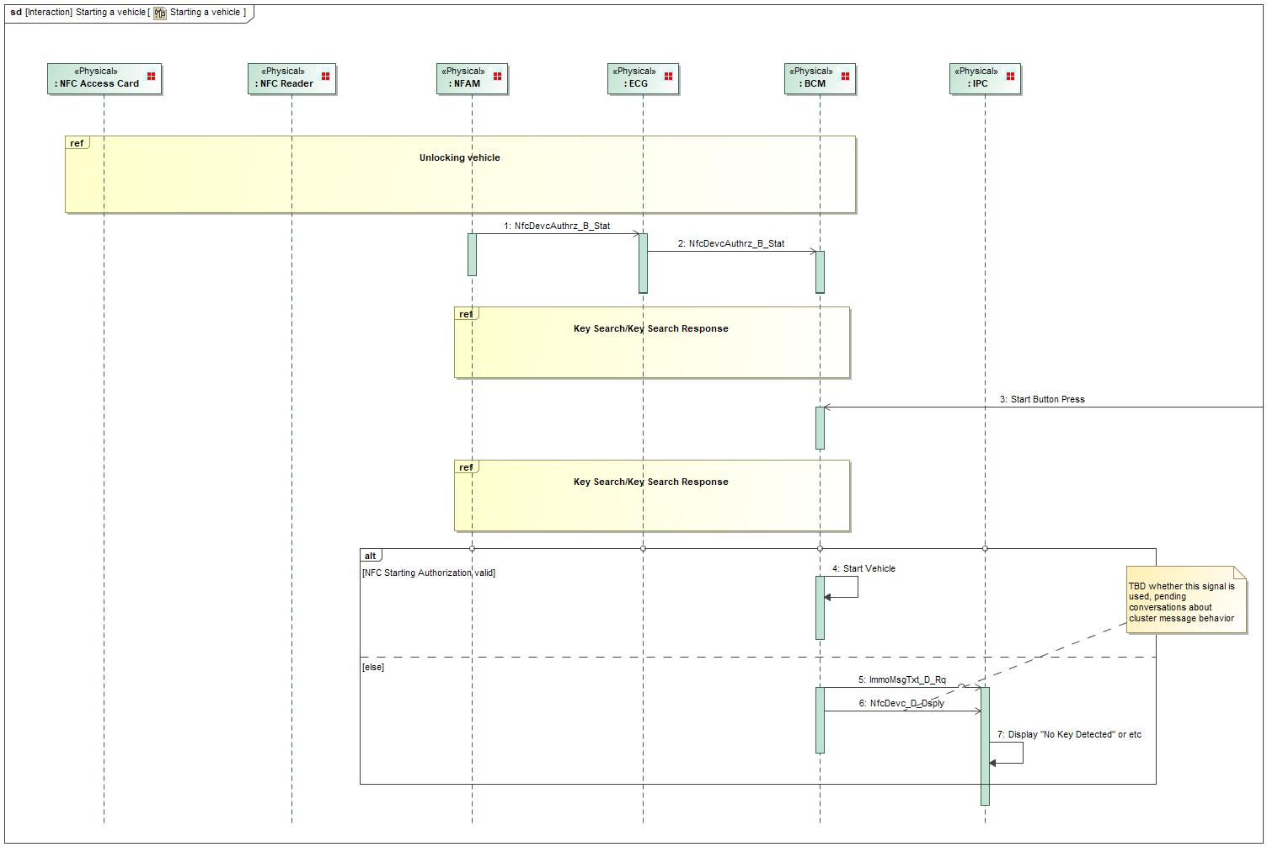

Figure 4: Starting a vehicle

### Scenario: “Pair NFC key card(s) (manufacturing)”

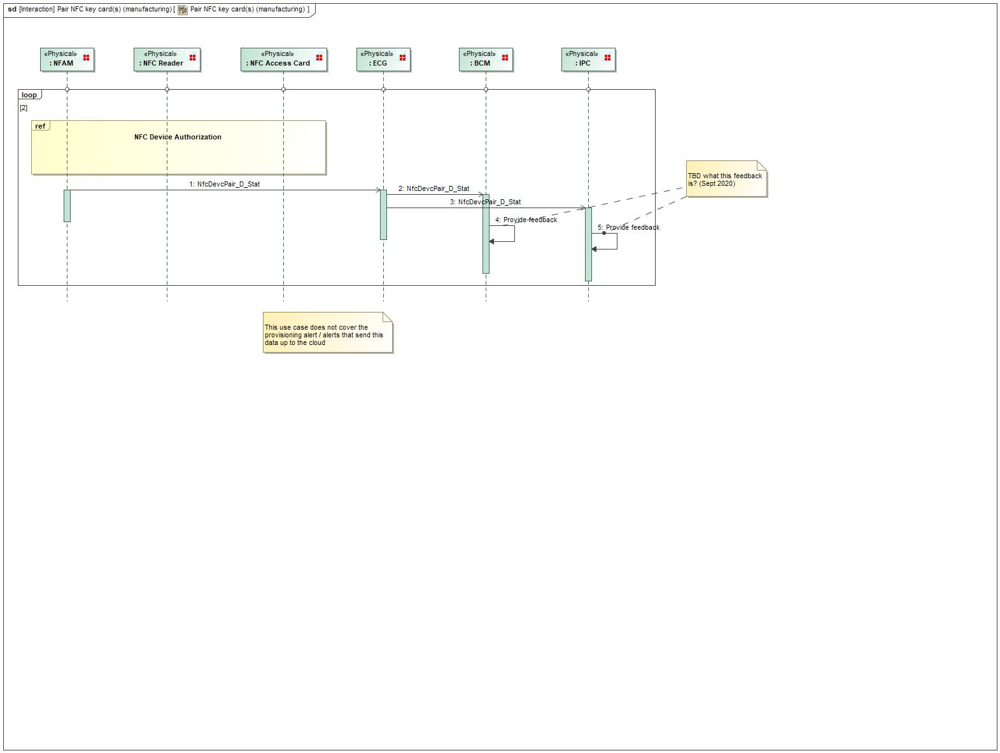

Figure 4: Pair NFC key card(s) (manufacturing)

### Scenario: “Provisioning”

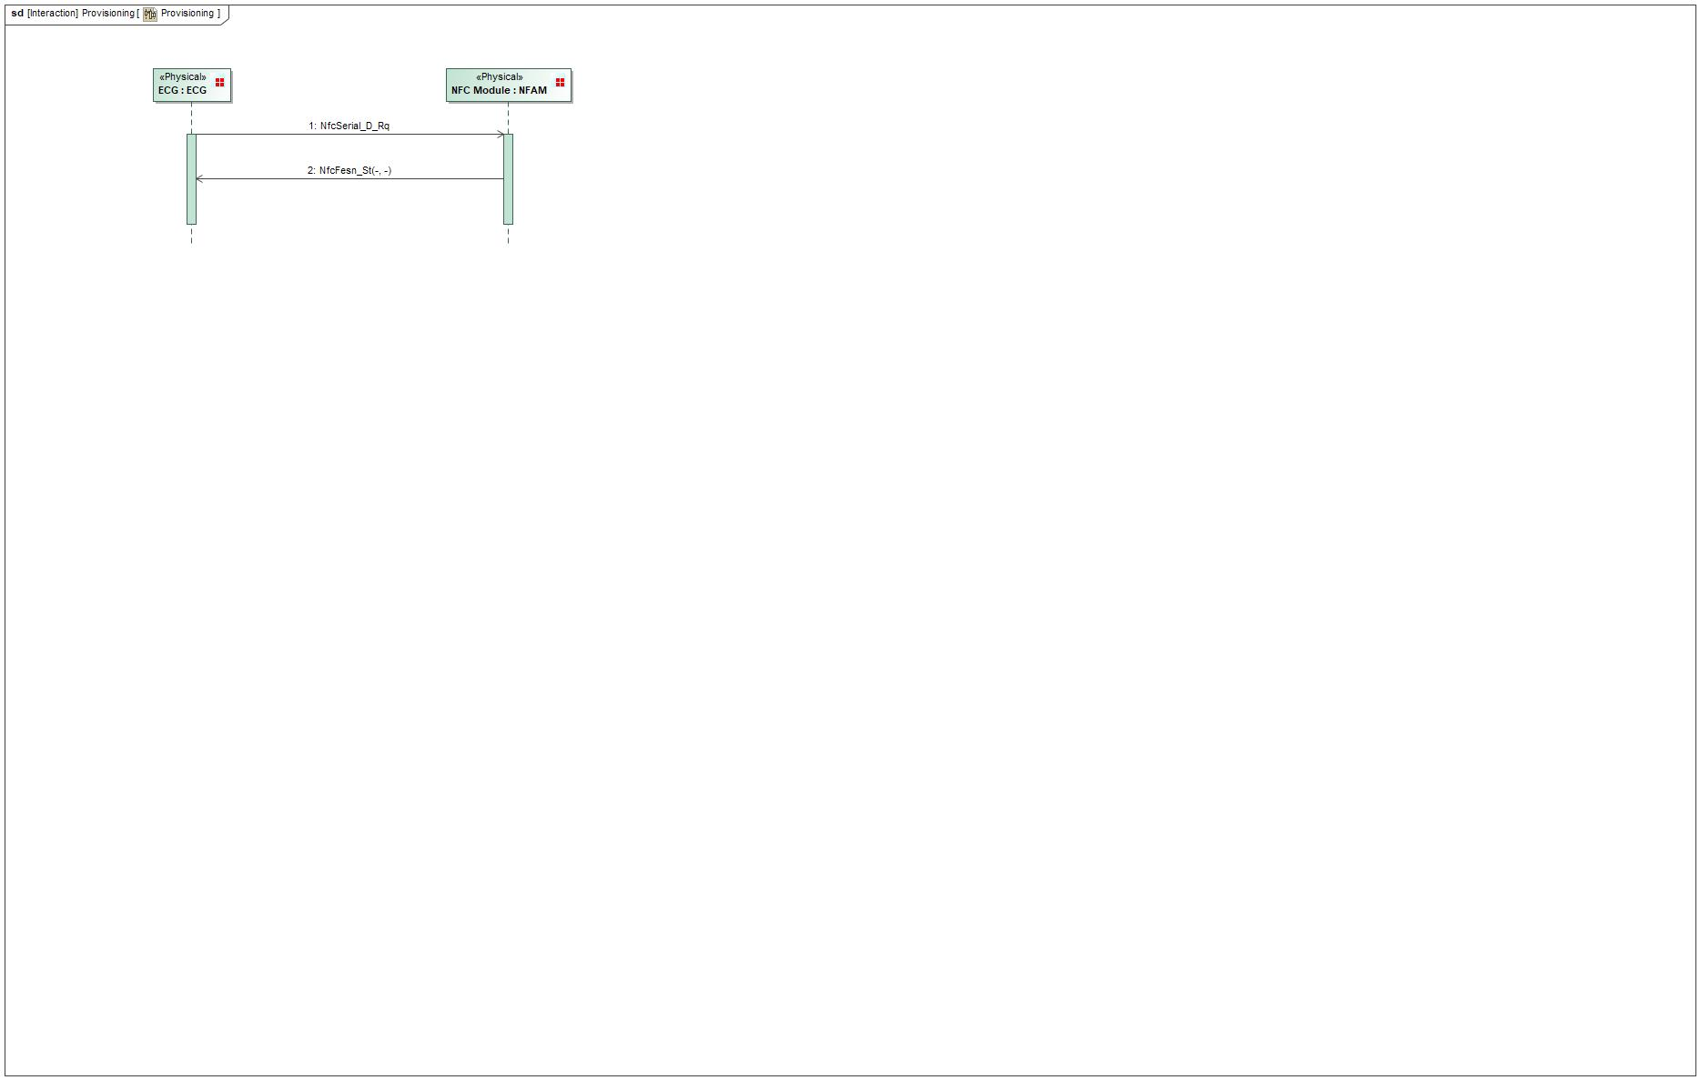

Figure 4: Provisioning

### Scenario: “Add an NFC key card - retail”

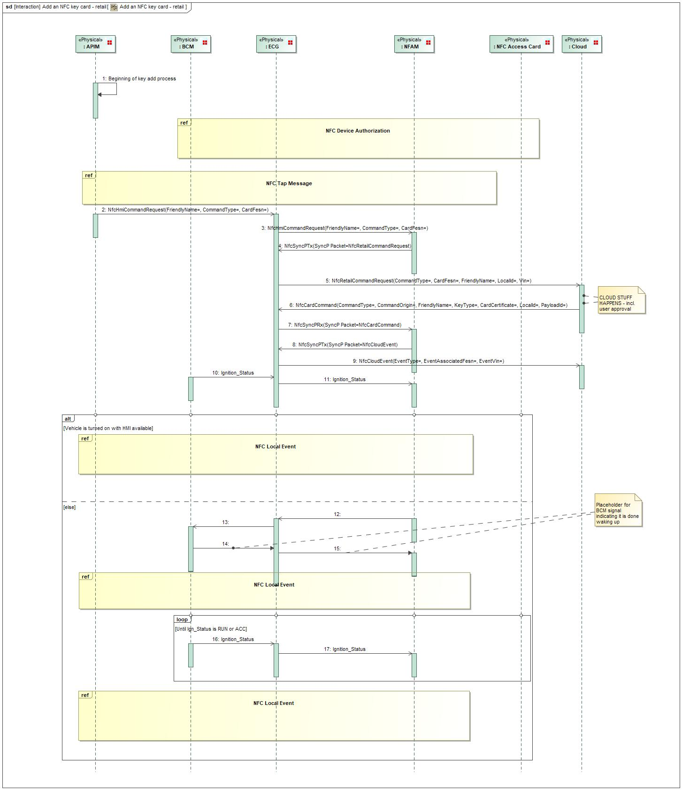

Figure 4: Add an NFC key card - retail

### Scenario: “Enter Motive State with an NFC Key following Remote Start”

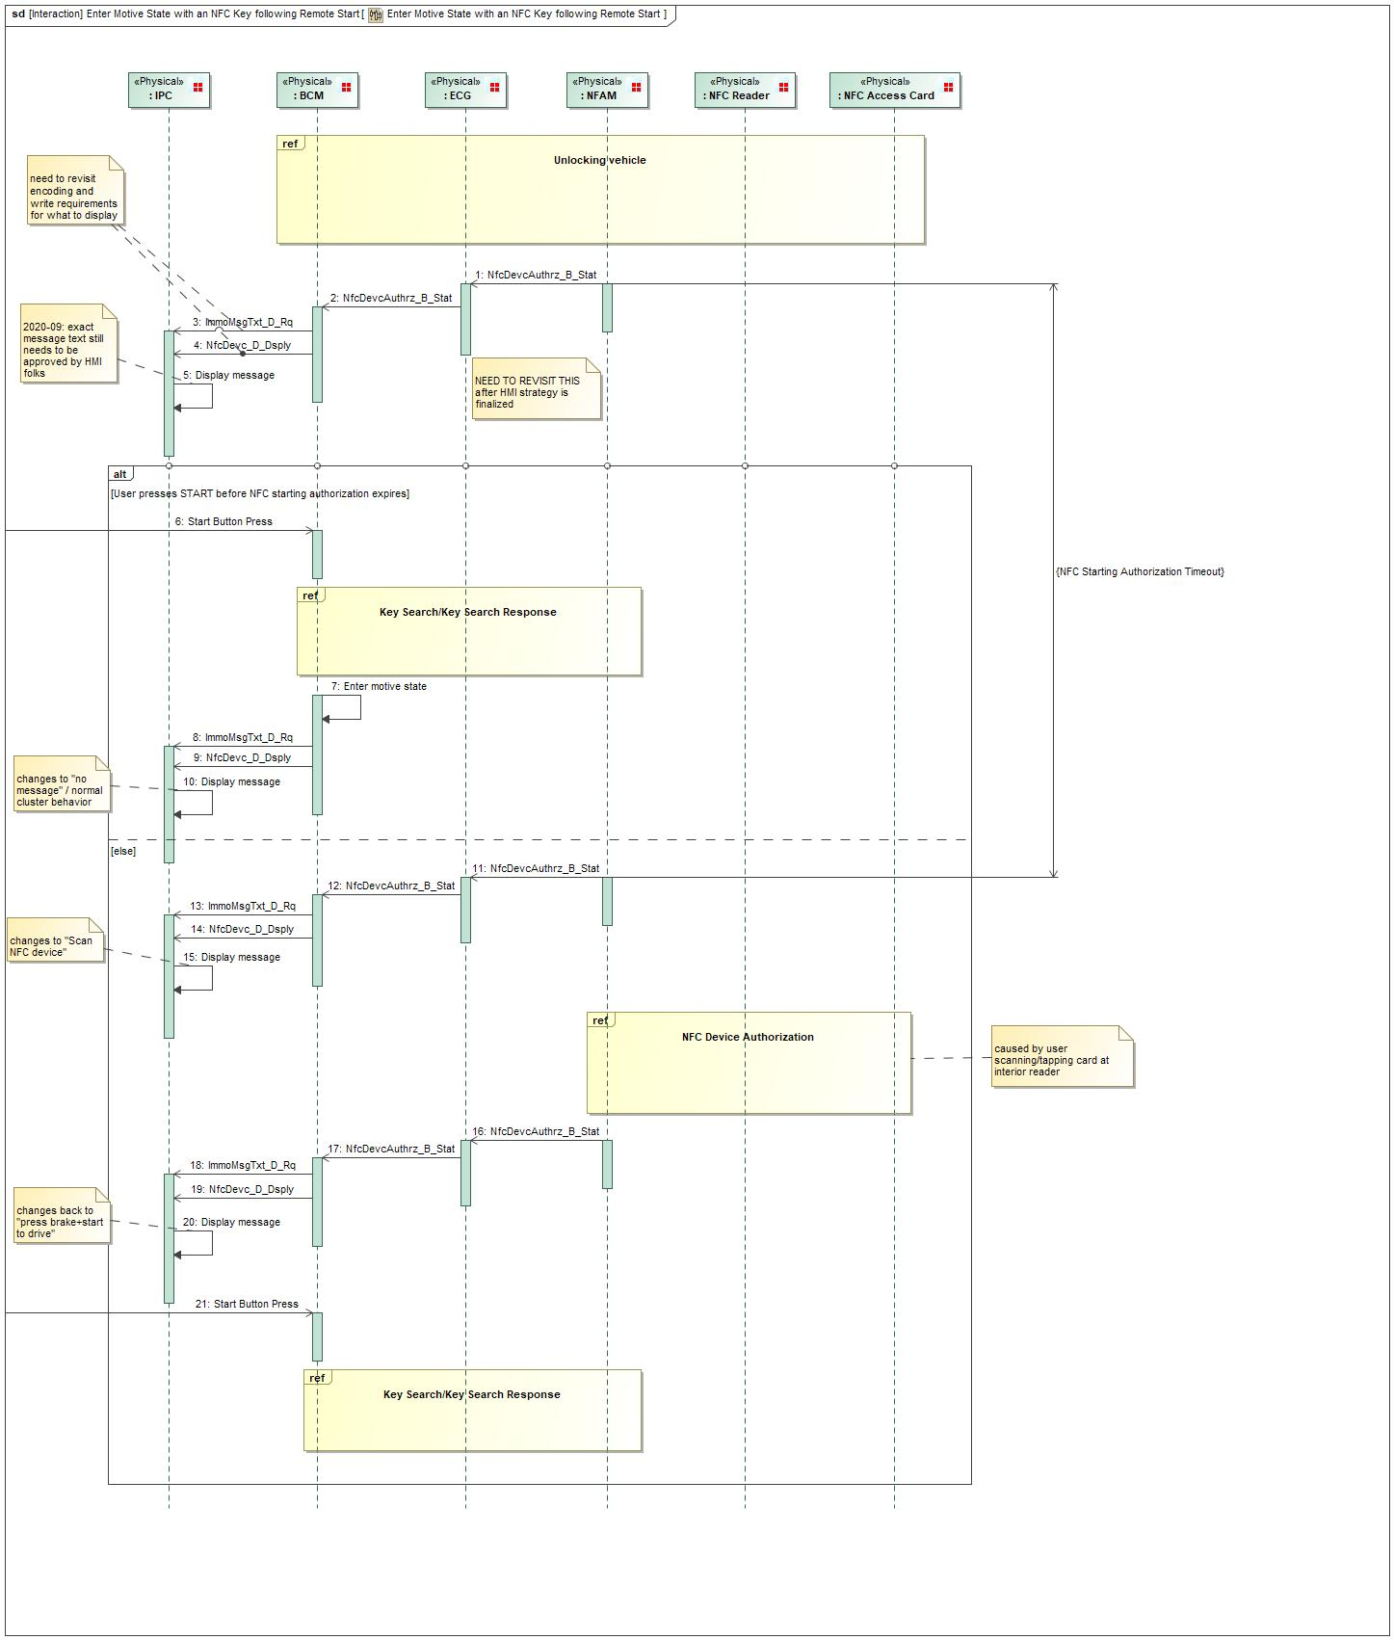

Figure 4: Enter Motive State with an NFC Key following Remote Start

### Scenario: “System Startup / Shutdown”

### Scenario: “Normal Operation”

#No “Feature Scenario Diagram” found

#

#

#

#

Figure 5:

See Section 5.2 for State Machine Diagram illustrating operation.

### Functional Safety

#### Fault Handling Time Analysis

| **Component/ Subsystem**  [or Communication Channel] | **F-S-Req-ID** | **Fault Handling Time (FHT)** | **T-S-Req-ID** | **Portion of the FHT**  [or Time Delay of Communication Channel] |
| --- | --- | --- | --- | --- |

Table 5‑1: Fault Handling Time Table

#### Requirements Derivation Diagram

## Component Interface Behavior Diagrams

The screens and flows of the in-vehicle display system that are relevant to the NFC Entry and Starting feature.

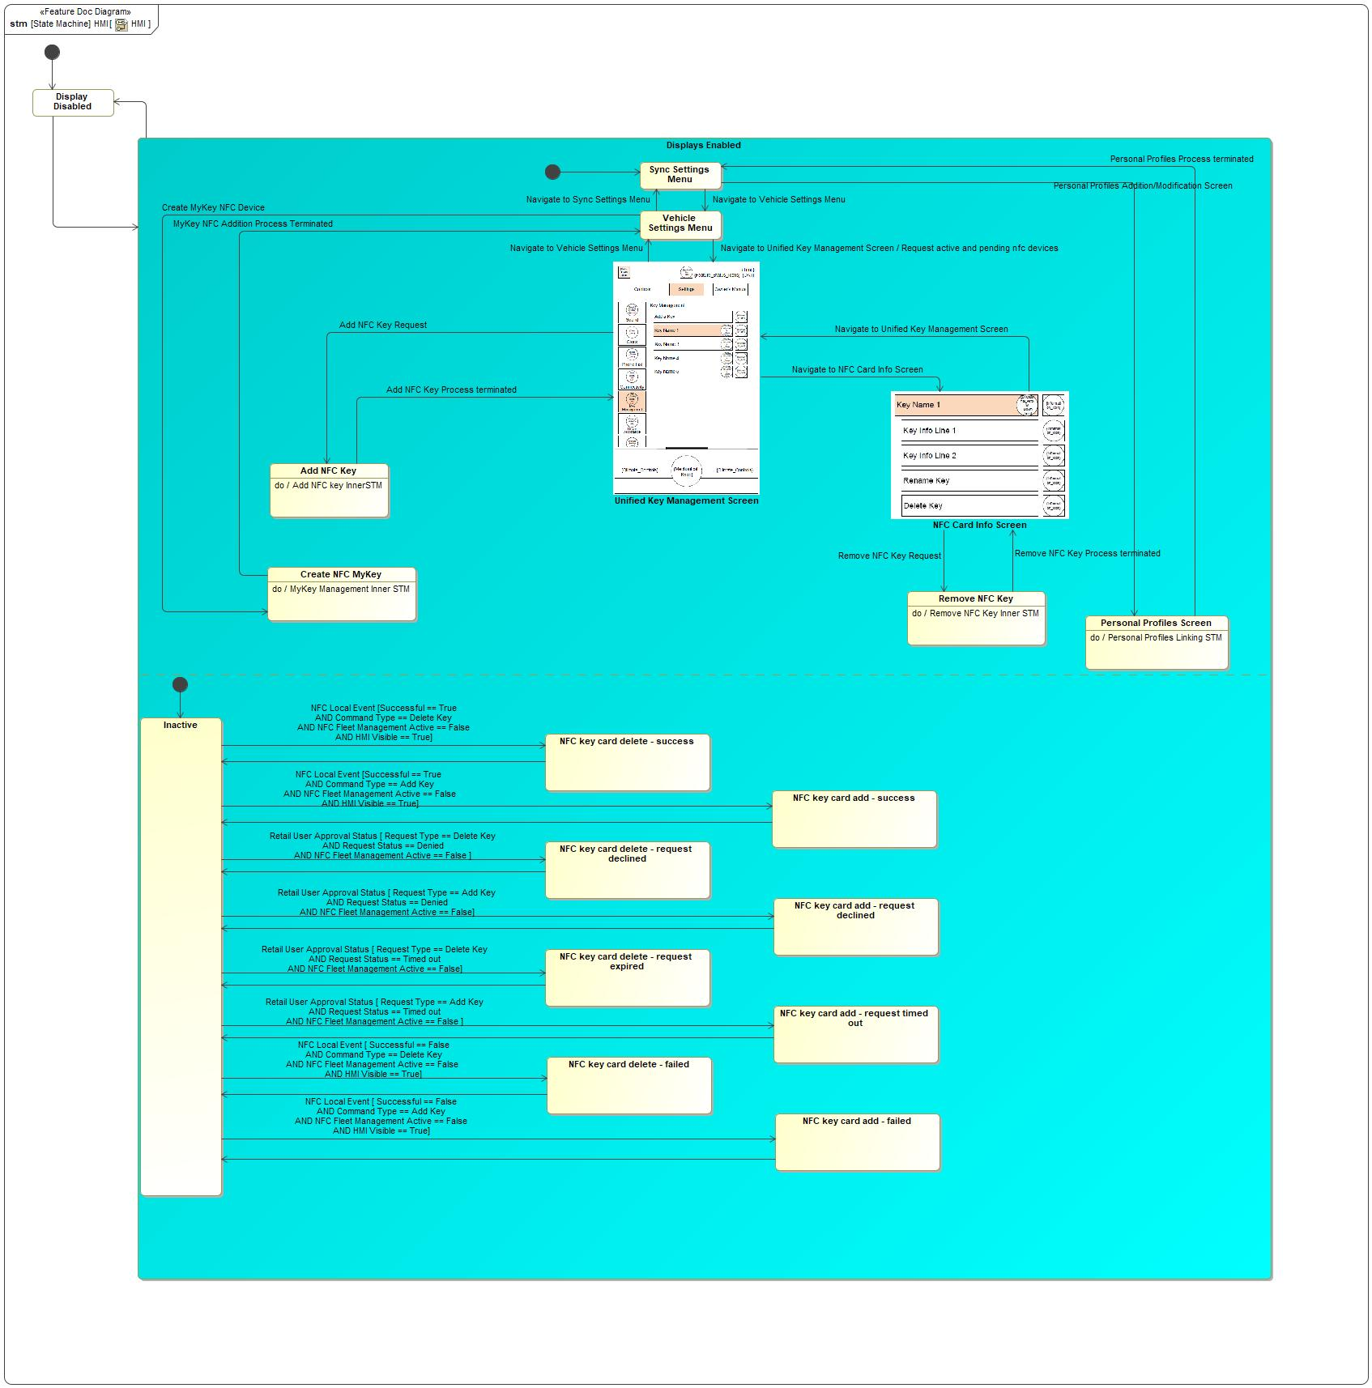

Figure 3: HMI

|  |  |  |
| --- | --- | --- |
| **State** | **Description** | **Requirements Reference** (optional) |
| Add NFC Key | Do behavior: Add NFC key InnerSTM |  |
| Create NFC MyKey | Do behavior: MyKey Management Inner STM |  |
| Display Disabled |  |  |
| Displays Enabled |  |  |
| Inactive |  |  |
| NFC Card Info Screen |  |  |
| NFC key card add - failed | The owner approved the add request, and the backend issued the add command appropriately, but some failure occurred on the vehicle that prevented the key add from being completed. |  |
| NFC key card add - request declined |  |  |
| NFC key card add - request timed out |  |  |
| NFC key card add - success |  |  |
| NFC key card delete - failed |  |  |
| NFC key card delete - request declined |  |  |
| NFC key card delete - request expired |  |  |
| NFC key card delete - success |  |  |
| Personal Profiles Screen | Do behavior: Personal Profiles Linking STM |  |
| Remove NFC Key | Do behavior: Remove NFC Key Inner STM |  |
| Sync Settings Menu |  |  |
| Unified Key Management Screen | Do behavior: Display NFC Key List |  |
| Vehicle Settings Menu |  |  |

Table 2: Operation Modes and States on HMI

|  |  |  |  |  |
| --- | --- | --- | --- | --- |
| **Transition ID** | **Source** | **Destination** | **Description** | **Requirements Reference**  (optional) |
| T1 | NFC Card Info Screen | Remove NFC Key | Trigger signal: Remove NFC Key Request  SignalEvent Remove NFC Key Request |  |
| T2 | NFC Card Info Screen | Unified Key Management Screen | Trigger signal: Navigate to Unified Key Management Screen  SignalEvent Navigate to Unified Key Management Screen |  |
| T3 | Remove NFC Key | NFC Card Info Screen | Trigger signal: Remove NFC Key Process terminated  SignalEvent Remove NFC Key Process terminated |  |
| T4 | NFC key card add - failed | Inactive |  |  |
| T5 | NFC key card add - request declined | Inactive |  |  |
| T6 | Personal Profiles Screen | Sync Settings Menu | Trigger signal: Personal Profiles Process terminated  SignalEvent Personal Profiles Process terminated |  |
| T7 | Vehicle Settings Menu | Unified Key Management Screen | Trigger signal: Navigate to Unified Key Management Screen  Effect: Request active and pending nfc devices  SignalEvent Navigate to Unified Key Management Screen |  |
| T8 | NFC key card delete - failed | Inactive |  |  |
| T9 | Unified Key Management Screen | Add NFC Key | Guard: =  Trigger signal: Add NFC Key Request  SignalEvent Add NFC Key Request |  |
| T10 | Unified Key Management Screen | NFC Card Info Screen | Trigger signal: Navigate to NFC Card Info Screen  SignalEvent Navigate to NFC Card Info Screen |  |
| T11 | NFC key card delete - request expired | Inactive |  |  |
| T12 | NFC key card delete - request declined | Inactive |  |  |
| T13 | Create NFC MyKey | Vehicle Settings Menu | Trigger signal: MyKey NFC Addition Process Terminated  SignalEvent MyKey NFC Addition Process Terminated |  |
| T14 | Inactive | NFC key card add - success | Guard: Successful == True AND Command Type == Add Key AN...  Trigger signal: NFC Local Event  SignalEvent NFC Local Event |  |
| T15 | Vehicle Settings Menu | Create NFC MyKey | Trigger signal: Create MyKey NFC Device  SignalEvent Create MyKey NFC Device |  |
| T16 |  |  |  |  |
| T17 |  |  |  |  |
| T18 | NFC key card add - success | Inactive |  |  |
| T19 | Inactive | NFC key card delete - request declined | Guard: Request Type == Delete Key AND Request Status == ...  Trigger signal: Retail User Approval Status  SignalEvent Retail User Approval Status |  |
| T20 |  |  |  |  |
| T21 | Inactive | NFC key card add - failed | Guard: Successful == False AND Command Type == Add Key A...  Trigger signal: NFC Local Event  SignalEvent NFC Local Event |  |
| T22 | Inactive | NFC key card delete - success | Guard: Successful == True AND Command Type == Delete Key ...  Trigger signal: NFC Local Event  SignalEvent NFC Local Event |  |
| T23 | Vehicle Settings Menu | Sync Settings Menu | Trigger signal: Navigate to Sync Settings Menu  SignalEvent Navigate to Sync Settings Menu |  |
| T24 | NFC key card delete - success | Inactive |  |  |
| T25 | Sync Settings Menu | Vehicle Settings Menu | Trigger signal: Navigate to Vehicle Settings Menu  SignalEvent Navigate to Vehicle Settings Menu |  |
| T26 | Inactive | NFC key card add - request timed out | Guard: Request Type == Add Key AND Request Status == Tim...  Trigger signal: Retail User Approval Status  SignalEvent Retail User Approval Status |  |
| T27 | Unified Key Management Screen | Vehicle Settings Menu | Trigger signal: Navigate to Vehicle Settings Menu  SignalEvent Navigate to Vehicle Settings Menu |  |
| T28 | Sync Settings Menu | Personal Profiles Screen | Trigger signal: Personal Profiles Addition/Modification Screen  SignalEvent Personal Profiles Addition/Modification Screen |  |
| T29 | Displays Enabled | Display Disabled |  |  |
| T30 | Inactive | NFC key card delete - failed | Guard: Successful == False AND Command Type == Delete Ke...  Trigger signal: NFC Local Event  SignalEvent NFC Local Event |  |
| T31 | Display Disabled | Displays Enabled |  |  |
| T32 | Inactive | NFC key card add - request declined | Guard: Request Type == Add Key AND Request Status == Den...  Trigger signal: Retail User Approval Status  SignalEvent Retail User Approval Status |  |
| T33 | Inactive | NFC key card delete - request expired | Guard: Request Type == Delete Key AND Request Status == ...  Trigger signal: Retail User Approval Status  SignalEvent Retail User Approval Status |  |
| T34 | Add NFC Key | Unified Key Management Screen | Trigger signal: Add NFC Key Process terminated  SignalEvent Add NFC Key Process terminated |  |
| T35 | NFC key card add - request timed out | Inactive |  |  |

Table 3: Transitions between Operation Modes and States on HMI

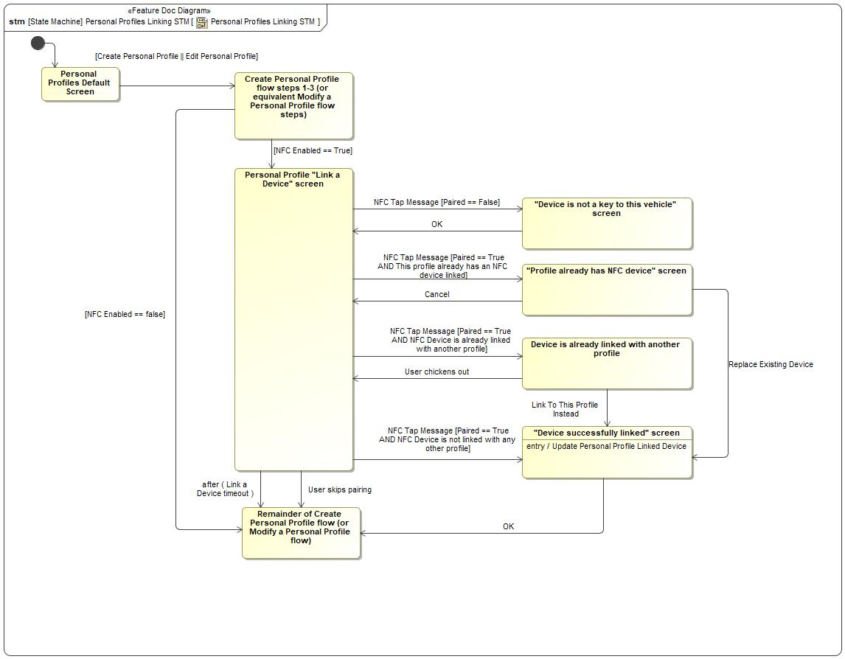

Figure 4: Personal Profiles Linking STM

|  |  |  |
| --- | --- | --- |
| **State** | **Description** | **Requirements Reference** (optional) |
| "Device is not a key to this vehicle" screen |  |  |
| "Device successfully linked" screen | Entry behavior: Update Personal Profile Linked Device |  |
| "Profile already has NFC device" screen |  |  |
| Create Personal Profile flow steps 1-3 (or equivalent Modify a Personal Profile flow steps) |  |  |
| Device is already linked with another profile |  |  |
| Personal Profile "Link a Device" screen |  |  |
| Personal Profiles Default Screen |  |  |
| Remainder of Create Personal Profile flow (or Modify a Personal Profile flow) |  |  |

Table 2: Operation Modes and States on Personal Profiles Linking STM

|  |  |  |  |  |
| --- | --- | --- | --- | --- |
| **Transition ID** | **Source** | **Destination** | **Description** | **Requirements Reference**  (optional) |
| T1 | Device is already linked with another profile | "Device successfully linked" screen | Name: User selects "Yes" - overwrite existing link  Trigger signal: Link To This Profile Instead  SignalEvent Link To This Profile Instead |  |
| T2 | "Profile already has NFC device" screen | Personal Profile "Link a Device" screen | Trigger signal: Cancel  SignalEvent Cancel |  |
| T3 | Personal Profile "Link a Device" screen | "Device is not a key to this vehicle" screen | Guard: =Paired == False  Trigger signal: NFC Tap Message  SignalEvent NFC Tap Message |  |
| T4 | "Device successfully linked" screen | Remainder of Create Personal Profile flow (or Modify a Personal Profile flow) | Trigger signal: OK  SignalEvent OK |  |
| T5 | "Profile already has NFC device" screen | "Device successfully linked" screen | Name: User selects "Yes" - replace existing device  Trigger signal: Replace Existing Device  SignalEvent Replace Existing Device |  |
| T6 | Personal Profile "Link a Device" screen | Remainder of Create Personal Profile flow (or Modify a Personal Profile flow) | Trigger signal: User skips pairing  SignalEvent User skips pairing |  |
| T7 | "Device is not a key to this vehicle" screen | Personal Profile "Link a Device" screen | Trigger signal: OK  SignalEvent OK |  |
| T8 | Personal Profile "Link a Device" screen | Remainder of Create Personal Profile flow (or Modify a Personal Profile flow) | TimeEvent after ( Link a Device timeout ) |  |
| T9 | Personal Profiles Default Screen | Create Personal Profile flow steps 1-3 (or equivalent Modify a Personal Profile flow steps) | Guard: =Create Personal Profile || Edit Personal ... |  |
| T10 |  |  |  |  |
| T11 | Create Personal Profile flow steps 1-3 (or equivalent Modify a Personal Profile flow steps) | Remainder of Create Personal Profile flow (or Modify a Personal Profile flow) | Guard: =NFC Enabled == false |  |
| T12 | Create Personal Profile flow steps 1-3 (or equivalent Modify a Personal Profile flow steps) | Personal Profile "Link a Device" screen | Guard: NFC Enabled == True |  |
| T13 | Personal Profile "Link a Device" screen | "Device successfully linked" screen | Guard: =Paired == True AND NFC Device is not link...  Trigger signal: NFC Tap Message  SignalEvent NFC Tap Message |  |
| T14 | Personal Profile "Link a Device" screen | Device is already linked with another profile | Guard: =Paired == True AND NFC Device is already...  Trigger signal: NFC Tap Message  SignalEvent NFC Tap Message |  |
| T15 | Device is already linked with another profile | Personal Profile "Link a Device" screen | Trigger signal: User chickens out  SignalEvent User chickens out |  |
| T16 | Personal Profile "Link a Device" screen | "Profile already has NFC device" screen | Guard: =Paired == True AND This profile already h...  Trigger signal: NFC Tap Message  SignalEvent NFC Tap Message |  |

Table 3: Transitions between Operation Modes and States on Personal Profiles Linking STM

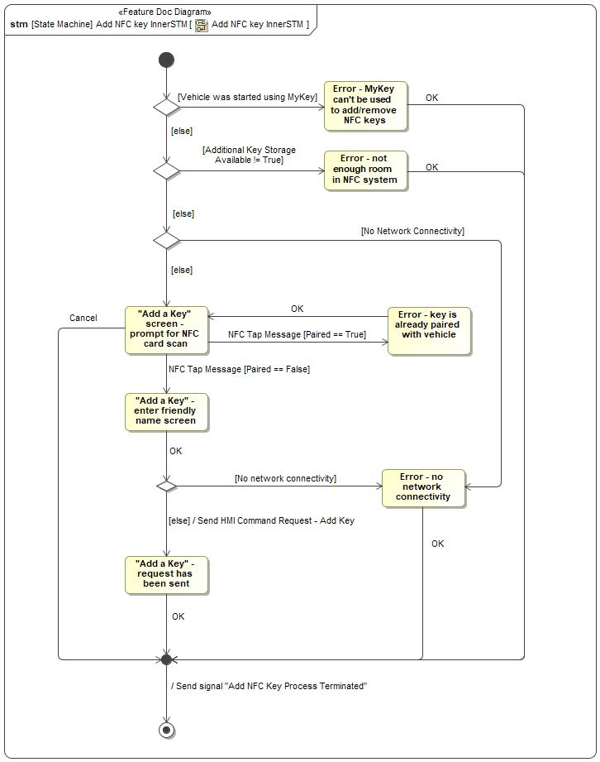

Figure 5: Add NFC key InnerSTM

|  |  |  |
| --- | --- | --- |
| **State** | **Description** | **Requirements Reference** (optional) |
| "Add a Key" - enter friendly name screen |  |  |
| "Add a Key" - request has been sent |  |  |
| "Add a Key" screen - prompt for NFC card scan |  |  |
| Error - key is already paired with vehicle |  |  |
| Error - MyKey can't be used to add/remove NFC keys |  |  |
| Error - no network connectivity |  |  |
| Error - not enough room in NFC system |  |  |

Table 2: Operation Modes and States on Add NFC key InnerSTM

|  |  |  |  |  |
| --- | --- | --- | --- | --- |
| **Transition ID** | **Source** | **Destination** | **Description** | **Requirements Reference**  (optional) |
| T1 |  |  |  |  |
| T2 | Error - key is already paired with vehicle | "Add a Key" screen - prompt for NFC card scan | Trigger signal: OK  SignalEvent OK |  |
| T3 | Error - not enough room in NFC system | a | Trigger signal: OK  SignalEvent OK |  |
| T4 | Error - MyKey can't be used to add/remove NFC keys | a | Trigger signal: OK  SignalEvent OK |  |
| T5 | "Add a Key" screen - prompt for NFC card scan | Error - key is already paired with vehicle | Guard: =Paired == True  Trigger signal: NFC Tap Message  SignalEvent NFC Tap Message |  |
| T6 | "Add a Key" - request has been sent | a | Trigger signal: OK  SignalEvent OK |  |
| T7 |  |  | Guard: =Vehicle was started using MyKey |  |
| T8 | "Add a Key" screen - prompt for NFC card scan | a | Trigger signal: Cancel  SignalEvent Cancel |  |
| T9 |  |  | Guard: Additional Key Storage Available != True |  |
| T10 |  |  | Guard: No network connectivity |  |
| T11 | "Add a Key" - enter friendly name screen | a | Trigger signal: OK  SignalEvent OK |  |
| T12 | "Add a Key" screen - prompt for NFC card scan | "Add a Key" - enter friendly name screen | Guard: =Paired == False  Trigger signal: NFC Tap Message  SignalEvent NFC Tap Message |  |
| T13 |  |  | Effect: End Add NFC Key flow |  |
| T14 |  |  | Guard: else  Effect: Send HMI Command Request - Add Key |  |
| T15 | Error - no network connectivity | a | Trigger signal: OK  SignalEvent OK |  |
| T16 |  |  | Guard: =No Network Connectivity |  |
| T17 |  |  | Guard: else |  |
| T18 |  |  | Guard: else |  |
| T19 |  |  | Guard: else |  |

Table 3: Transitions between Operation Modes and States on Add NFC key InnerSTM

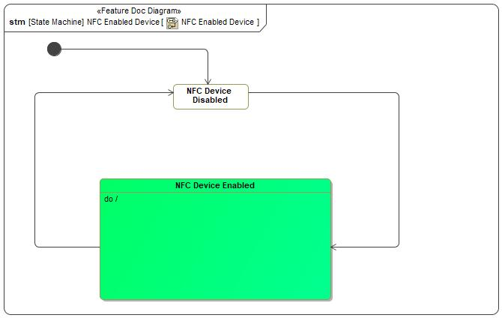

Figure 6: NFC Enabled Device

|  |  |  |
| --- | --- | --- |
| **State** | **Description** | **Requirements Reference** (optional) |
| NFC Device Disabled |  |  |
| NFC Device Enabled |  |  |

Table 2: Operation Modes and States on NFC Enabled Device

|  |  |  |  |  |
| --- | --- | --- | --- | --- |
| **Transition ID** | **Source** | **Destination** | **Description** | **Requirements Reference**  (optional) |
| T1 | NFC Device Disabled | NFC Device Enabled | SignalEvent |  |
| T2 |  |  |  |  |
| T3 | NFC Device Enabled | NFC Device Disabled | SignalEvent |  |

Table 3: Transitions between Operation Modes and States on NFC Enabled Device

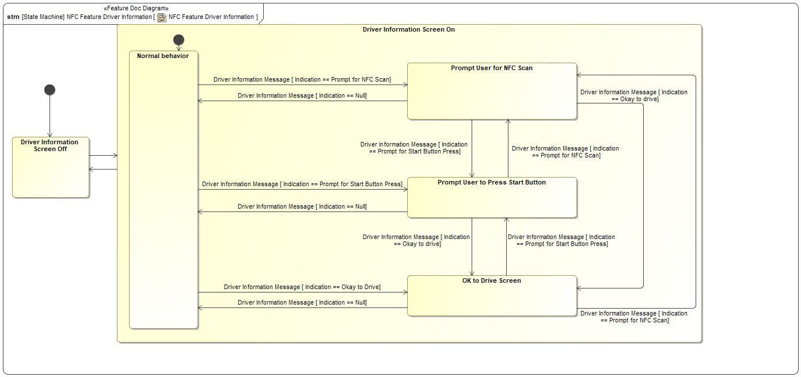

Figure 7: NFC Feature Driver Information

|  |  |  |
| --- | --- | --- |
| **State** | **Description** | **Requirements Reference** (optional) |
| Driver Information Screen Off |  |  |
| Driver Information Screen On |  |  |
| Normal behavior |  |  |
| OK to Drive Screen | This screen gives feedback to the user in the Secure Idle case - the user can exit Secure Idle by scanning an NFC device, and in this case there is no feedback indicating a successful scan except this screen. |  |
| Prompt User for NFC Scan |  |  |
| Prompt User to Press Start Button |  |  |

Table 2: Operation Modes and States on NFC Feature Driver Information

|  |  |  |  |  |
| --- | --- | --- | --- | --- |
| **Transition ID** | **Source** | **Destination** | **Description** | **Requirements Reference**  (optional) |
| T1 | Prompt User to Press Start Button | OK to Drive Screen | Guard: Indication == Okay to drive  Trigger signal: Driver Information Message  SignalEvent Driver Information Message |  |
| T2 | OK to Drive Screen | Prompt User to Press Start Button | Guard: Indication == Prompt for Start Button Press  Trigger signal: Driver Information Message  SignalEvent Driver Information Message |  |
| T3 |  |  |  |  |
| T4 | Prompt User to Press Start Button | Normal behavior | Guard: Indication == Null  Trigger signal: Driver Information Message  SignalEvent Driver Information Message |  |
| T5 | Driver Information Screen On | Driver Information Screen Off |  |  |
| T6 |  |  |  |  |
| T7 | Driver Information Screen Off | Driver Information Screen On |  |  |
| T8 | Normal behavior | Prompt User for NFC Scan | Guard: Indication == Prompt for NFC Scan  Trigger signal: Driver Information Message  SignalEvent Driver Information Message |  |
| T9 | Prompt User for NFC Scan | OK to Drive Screen | Guard: Indication == Okay to drive  Trigger signal: Driver Information Message  SignalEvent Driver Information Message |  |
| T10 | Prompt User for NFC Scan | Prompt User to Press Start Button | Name: ..Driver Information Message [ Indication == Prompt for Start Button Press]  Guard: Indication == Prompt for Start Button Press  Trigger signal: Driver Information Message  SignalEvent Driver Information Message |  |
| T11 | OK to Drive Screen | Normal behavior | Guard: Indication == Null  Trigger signal: Driver Information Message  SignalEvent Driver Information Message |  |
| T12 | Normal behavior | OK to Drive Screen | Guard: Indication == Okay to Drive  Trigger signal: Driver Information Message  SignalEvent Driver Information Message |  |
| T13 | Prompt User to Press Start Button | Prompt User for NFC Scan | Guard: Indication == Prompt for NFC Scan  Trigger signal: Driver Information Message  SignalEvent Driver Information Message |  |
| T14 | Prompt User for NFC Scan | Normal behavior | Guard: Indication == Null  Trigger signal: Driver Information Message  SignalEvent Driver Information Message |  |
| T15 | Normal behavior | Prompt User to Press Start Button | Guard: Indication == Prompt for Start Button Press  Trigger signal: Driver Information Message  SignalEvent Driver Information Message |  |
| T16 | OK to Drive Screen | Prompt User for NFC Scan | Guard: Indication == Prompt for NFC Scan  Trigger signal: Driver Information Message  SignalEvent Driver Information Message |  |

Table 3: Transitions between Operation Modes and States on NFC Feature Driver Information

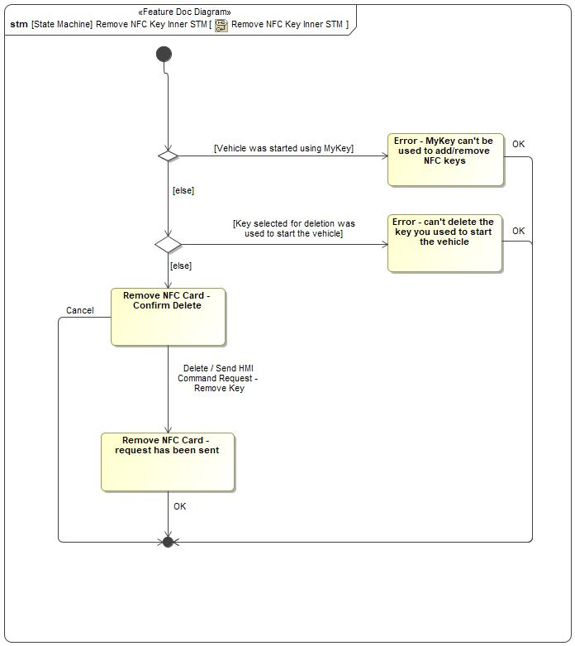

Figure 8: Remove NFC Key Inner STM

|  |  |  |
| --- | --- | --- |
| **State** | **Description** | **Requirements Reference** (optional) |
| Error - can't delete the key you used to start the vehicle | The key that the user selected for deletion is the key that was used to start the vehicle. You can't delete the key you used to start the vehicle. To delete this key, turn the car off and start it with a different key. |  |
| Error - MyKey can't be used to add/remove NFC keys |  |  |
| Remove NFC Card - Confirm Delete | Confirm that the user wants to delete the specified NFC key - it will no longer be able to open or start the vehicle. |  |
| Remove NFC Card - request has been sent |  |  |

Table 2: Operation Modes and States on Remove NFC Key Inner STM

|  |  |  |  |  |
| --- | --- | --- | --- | --- |
| **Transition ID** | **Source** | **Destination** | **Description** | **Requirements Reference**  (optional) |
| T1 | Remove NFC Card - request has been sent | a | Trigger signal: OK  SignalEvent OK |  |
| T2 |  |  | Guard: else |  |
| T3 |  |  | Guard: Key selected for deletion was used to start the ve... |  |
| T4 | Error - can't delete the key you used to start the vehicle | a | Trigger signal: OK  SignalEvent OK |  |
| T5 | Remove NFC Card - Confirm Delete | a | Trigger signal: Cancel  SignalEvent Cancel |  |
| T6 |  |  | Guard: else |  |
| T7 | Error - MyKey can't be used to add/remove NFC keys | a | Trigger signal: OK  SignalEvent OK |  |
| T8 | Remove NFC Card - Confirm Delete | Remove NFC Card - request has been sent | Trigger signal: Delete  Effect: Send HMI Command Request - Remove Key  SignalEvent Delete |  |
| T9 |  |  | Guard: Vehicle was started using MyKey |  |
| T10 |  |  |  |  |

Table 3: Transitions between Operation Modes and States on Remove NFC Key Inner STM

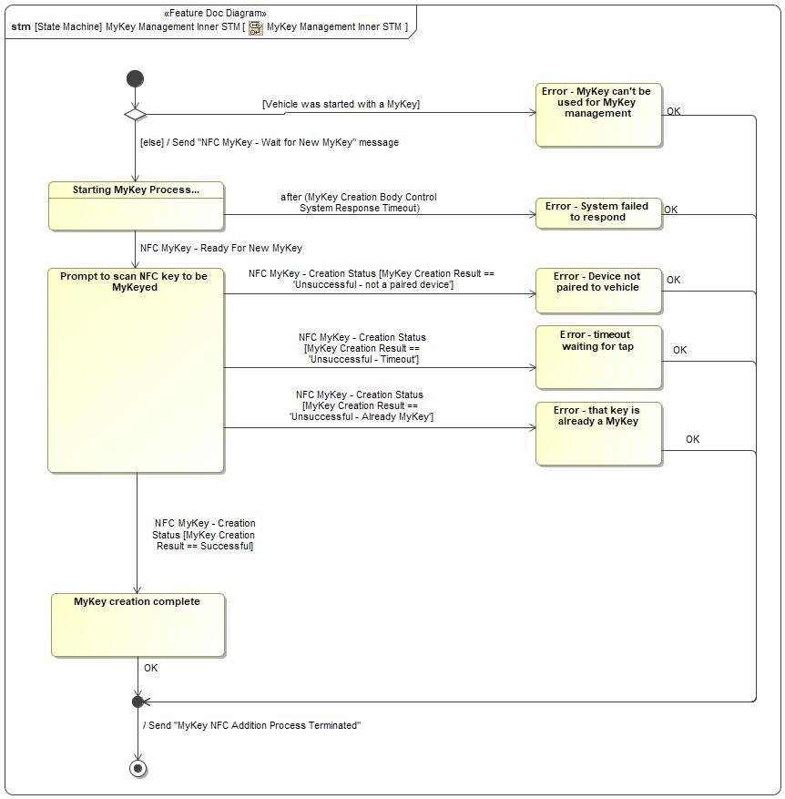

Figure 9: MyKey Management Inner STM

|  |  |  |
| --- | --- | --- |
| **State** | **Description** | **Requirements Reference** (optional) |
| Error - Device not paired to vehicle |  |  |
| Error - MyKey can't be used for MyKey management | The vehicle was started using a key with MyKey restrictions. MyKey management is not available. To create MyKeys or reset the MyKey system, turn the car off and start it again with a standard key. |  |
| Error - System failed to respond |  |  |
| Error - that key is already a MyKey |  |  |
| Error - timeout waiting for tap |  |  |
| MyKey creation complete |  |  |
| Prompt to scan NFC key to be MyKeyed |  |  |
| Starting MyKey Process... | Entry behavior: Start MyKey Process |  |

Table 2: Operation Modes and States on MyKey Management Inner STM

|  |  |  |  |  |
| --- | --- | --- | --- | --- |
| **Transition ID** | **Source** | **Destination** | **Description** | **Requirements Reference**  (optional) |
| T1 |  |  | Guard: =Vehicle was started with a MyKey |  |
| T2 | Error - Device not paired to vehicle | a | Trigger signal: OK  SignalEvent OK |  |
| T3 |  |  |  |  |
| T4 | Starting MyKey Process... | Error - System failed to respond | TimeEvent after (MyKey Creation Body Control System Response Timeout) |  |
| T5 | Error - timeout waiting for tap | a | Trigger signal: OK  SignalEvent OK |  |
| T6 |  |  | Effect: End MyKey add process |  |
| T7 | Starting MyKey Process... | Prompt to scan NFC key to be MyKeyed | Guard: =  Trigger signal: NFC MyKey - Ready For New MyKey  SignalEvent NFC MyKey - Ready For New MyKey |  |
| T8 |  |  | Guard: =else  Effect: Trigger MyKey Creation On Body Control System |  |
| T9 | Prompt to scan NFC key to be MyKeyed | Error - timeout waiting for tap | Guard: MyKey Creation Result == 'Unsuccessful - Timeout'  Trigger signal: NFC MyKey - Creation Status  SignalEvent NFC MyKey - Creation Status |  |
| T10 | Prompt to scan NFC key to be MyKeyed | MyKey creation complete | Guard: =MyKey Creation Result == Successful  Trigger signal: NFC MyKey - Creation Status  SignalEvent NFC MyKey - Creation Status |  |
| T11 | Error - System failed to respond | a | Trigger signal: OK  SignalEvent OK |  |
| T12 | Error - MyKey can't be used for MyKey management | a | Trigger signal: OK  SignalEvent OK |  |
| T13 | Prompt to scan NFC key to be MyKeyed | Error - Device not paired to vehicle | Guard: MyKey Creation Result == 'Unsuccessful - not a pa...  Trigger signal: NFC MyKey - Creation Status  SignalEvent NFC MyKey - Creation Status |  |
| T14 | Error - that key is already a MyKey | a | Trigger signal: OK  SignalEvent OK |  |
| T15 | MyKey creation complete | a | Trigger signal: OK  SignalEvent OK |  |
| T16 | Prompt to scan NFC key to be MyKeyed | Error - that key is already a MyKey | Guard: =MyKey Creation Result == 'Unsuccessful - ...  Trigger signal: NFC MyKey - Creation Status  SignalEvent NFC MyKey - Creation Status |  |

Table 3: Transitions between Operation Modes and States on MyKey Management Inner STM

# Feature Implementation Requirements

## Functional Safety

## Requirements on Components

### 2041763009.jpg BCM

#TODO: add a table of the reqs allocated?

#### Technology Function 589838672.jpg **Deauthorize NFC Starting_BCM**

###### Outputs

|  |  |  |  |
| --- | --- | --- | --- |
| **Output** | **Technical Signal Encoding** | **Logical Signal** | **Type** |
| 203568040.jpg NfcDevcAuthrzT_B_Rq | 1565755635.jpg NullValid_ET | Trigger Deauthorization | CANSignal |

Table 2‑2: Output Signal mappings of Function Deauthorize NFC Starting_BCM

###### Parameters

|  |  |  |  |
| --- | --- | --- | --- |
| **Technical Parameter** | | **Method** | **Method Details** |
| **Name** | **Encoding** |

Table 2‑3: Parameter mappings of Function Deauthorize NFC Starting_BCM

#

#

#### Technology Function 589838672.jpg **Handle NFC Local Event_BCM**

###### Inputs

|  |  |  |  |
| --- | --- | --- | --- |
| **Input** | **Technical Signal Encoding** | **Logical Signal** | **Type** |
| 203568040.jpg NfcDevc_D_Cmd | NfcDevcCmd_D_Rq_ET |  | CANSignal |
| 203568040.jpg NfcDevc_D_Stat | SuccessFailNull_D_ET |  | CANSignal |
| 203568040.jpg NfcDevcCmd_No_Actl | UnitlessValue8bit_ET |  | CANSignal |

Table 2‑1: Input Signal mappings of Function Handle NFC Local Event_BCM

#

#

#### Technology Function 2003436423.jpg **Handle NFC Tap_BCM**

###### Inputs

|  |  |  |  |
| --- | --- | --- | --- |
| **Input** | **Technical Signal Encoding** | **Logical Signal** | **Type** |
| -1901142228.jpg DoorLockState |  |  | Signal |
| -1901142228.jpg WaitingForNewNfcMyKey |  |  | Signal |
| -1901142228.jpg SecureIdleStatus |  |  | Signal |
| 203568040.jpg NfcDevcTapPard_B_Stat | YesNo_ET |  | CANSignal |
| 203568040.jpg NfcDevcDetct_D_Stat | NFCDevcDetct_D_Stat |  | CANSignal |
| 203568040.jpg NfcDevcTapDur_D_Stat | LongShortNull_D_ET |  | CANSignal |
| 203568040.jpg NfcDevcTapId_No_Actl | UnitlessValue8bit_ET |  | CANSignal |
| 203568040.jpg NfcDevcTapDurDStat_No_Cnt | UnitlessValue4bit_ET |  | CANSignal |
| 203568040.jpg NfcDevcTapDurDStat_No_Crc | UnitlessValue8bit_ET |  | CANSignal |
| 203568040.jpg NfcDevcTapPardBStat_No_Cnt | UnitlessValue4bit_ET |  | CANSignal |
| 203568040.jpg NfcDevcTapPardBStat_No_Crc | UnitlessValue8bit_ET |  | CANSignal |

Table 2‑1: Input Signal mappings of Function Handle NFC Tap_BCM

###### Outputs

|  |  |  |  |
| --- | --- | --- | --- |
| **Output** | **Technical Signal Encoding** | **Logical Signal** | **Type** |
| -1901142228.jpg WaitingForNewNfcMyKey |  |  | Signal |
| 203568040.jpg NfcMyKeyCreate_D_Stat | 1565755635.jpg NfcMyKeyCreate_D_Stat_ET | NFC MyKey - Creation Status  NFC MyKey Creation Status  NFC MyKey - Ready For New MyKey | CANSignal |
| 203568040.jpg KeyMykeysTot_No_Actl | 1565755635.jpg UnitlessValue8bit_ET | NFC MyKey - Creation Status | CANSignal |
| 203568040.jpg AdminMyKeyTot_No_Actl | 1565755635.jpg UnitlessValue8bit_ET | NFC MyKey - Creation Status | CANSignal |

Table 2‑2: Output Signal mappings of Function Handle NFC Tap_BCM

#

#

#### Technology Function 589838672.jpg **Handle Start Button Press_BCM**

###### Inputs

|  |  |  |  |
| --- | --- | --- | --- |
| **Input** | **Technical Signal Encoding** | **Logical Signal** | **Type** |
| -1901142228.jpg RemoteStartStatus |  |  | Signal |
| -1901142228.jpg IgnitionStatus |  |  | Signal |
| -284636355.jpg NfcKeySearchResponseMessage |  |  | CANMessage |
| 203568040.jpg NfcDevcSearch_No_Actl | UnitlessValue3bit_ET |  | CANSignal |
| 203568040.jpg NfcDevcSearch_No_Rq | UnitlessValue3bit_ET |  | CANSignal |
| 203568040.jpg NfcDevcSearch_B_Rq | ActiveInactive_ET |  | CANSignal |
| 203568040.jpg NfcDevcSearchBRq_No_Cnt | UnitlessValue4bit_ET |  | CANSignal |
| 203568040.jpg NfcDevcSearchBRq_No_Crc | UnitlessValue8bit_ET |  | CANSignal |

Table 2‑1: Input Signal mappings of Function Handle Start Button Press_BCM

###### Outputs

|  |  |  |  |
| --- | --- | --- | --- |
| **Output** | **Technical Signal Encoding** | **Logical Signal** | **Type** |
| -1901142228.jpg StartingKeyType |  |  | Signal |
| -284636355.jpg NfcKeySearchMessage |  | Key Search Request | CANMessage |

Table 2‑2: Output Signal mappings of Function Handle Start Button Press_BCM

#

#

#### Technology Function 2003436423.jpg **Interpret Tap_BCM**

###### Inputs

|  |  |  |  |
| --- | --- | --- | --- |
| **Input** | **Technical Signal Encoding** | **Logical Signal** | **Type** |
| 203568040.jpg NfcDevcTapDur_D_Stat | LongShortNull_D_ET |  | CANSignal |
| -1901142228.jpg DoorLockState |  |  | Signal |
| 203568040.jpg NfcDevcTapDurDStat_No_Cnt | UnitlessValue4bit_ET |  | CANSignal |
| 203568040.jpg NfcDevcTapDurDStat_No_Crc | UnitlessValue8bit_ET |  | CANSignal |

Table 2‑1: Input Signal mappings of Function Interpret Tap_BCM

###### Outputs

|  |  |  |  |
| --- | --- | --- | --- |
| **Output** | **Technical Signal Encoding** | **Logical Signal** | **Type** |
|  |  |  |  |

Table 2‑2: Output Signal mappings of Function Interpret Tap_BCM

#

#

#### Technology Function 2003436423.jpg **Monitor MyKey Creation Status_BCM**

###### Inputs

|  |  |  |  |
| --- | --- | --- | --- |
| **Input** | **Technical Signal Encoding** | **Logical Signal** | **Type** |
| 203568040.jpg KeyMykeysTot_No_Actl | UnitlessValue8bit_ET |  | CANSignal |
| 203568040.jpg AdminMyKeyTot_No_Actl | UnitlessValue8bit_ET |  | CANSignal |

Table 2‑1: Input Signal mappings of Function Monitor MyKey Creation Status_BCM

###### Outputs

|  |  |  |  |
| --- | --- | --- | --- |
| **Output** | **Technical Signal Encoding** | **Logical Signal** | **Type** |
| -1901142228.jpg WaitingForNewNfcMyKey |  |  | Signal |
| 203568040.jpg NfcMyKeyCreate_D_Stat | 1565755635.jpg NfcMyKeyCreate_D_Stat_ET | NFC MyKey - Creation Status  NFC MyKey Creation Status  NFC MyKey - Ready For New MyKey | CANSignal |
| 203568040.jpg NfcMyKeyCreate_D_Stat | 1565755635.jpg NfcMyKeyCreate_D_Stat_ET | NFC MyKey - Creation Status  NFC MyKey Creation Status  NFC MyKey - Ready For New MyKey | CANSignal |

Table 2‑2: Output Signal mappings of Function Monitor MyKey Creation Status_BCM

#

#

#### Technology Function 2003436423.jpg **Set NFC MyKey State_BCM**

###### Inputs

|  |  |  |  |
| --- | --- | --- | --- |
| **Input** | **Technical Signal Encoding** | **Logical Signal** | **Type** |
| 203568040.jpg NfcDevcCmd_No_Actl | UnitlessValue8bit_ET |  | CANSignal |

Table 2‑1: Input Signal mappings of Function Set NFC MyKey State_BCM

###### Outputs

|  |  |  |  |
| --- | --- | --- | --- |
| **Output** | **Technical Signal Encoding** | **Logical Signal** | **Type** |
|  |  |  |  |

Table 2‑2: Output Signal mappings of Function Set NFC MyKey State_BCM

#

#

#### Technology Function 2003436423.jpg **Transmit body control system related indication_BCM**

###### Inputs

|  |  |  |  |
| --- | --- | --- | --- |
| **Input** | **Technical Signal Encoding** | **Logical Signal** | **Type** |
| -434625463.jpg input |  |  | Association |

Table 2‑1: Input Signal mappings of Function Transmit body control system related indication_BCM

#

#

### -2040462993.jpg NFAM

#TODO: add a table of the reqs allocated?

#### Technology Function 2003436423.jpg **Authorize Starting_NFAM**

###### Inputs

|  |  |  |  |
| --- | --- | --- | --- |
| **Input** | **Technical Signal Encoding** | **Logical Signal** | **Type** |
| -1901142228.jpg LastAuthorizedKey |  |  | Signal |
| -1901142228.jpg StartingAuthorized |  |  | Signal |
|  |  |  |  |
|  |  |  |  |

Table 2‑1: Input Signal mappings of Function Authorize Starting_NFAM

###### Outputs

|  |  |  |  |
| --- | --- | --- | --- |
| **Output** | **Technical Signal Encoding** | **Logical Signal** | **Type** |
| 203568040.jpg NfcDevcKeyType_D_Stat | 1565755635.jpg UserFactoryNull_D_ET | Authorizing key type | CANSignal |
| 203568040.jpg NfcDevcTapId_No_Actl | 1565755635.jpg UnitlessValue8bit_ET | Key Index | CANSignal |
| 203568040.jpg NfcDevcSearch_B_Stat | 1565755635.jpg ValidInvalidNull_ET | Authorized | CANSignal |
| 203568040.jpg NfcDevcSearch_No_Actl | 1565755635.jpg UnitlessValue3bit_ET | Key Search Response | CANSignal |
| 203568040.jpg NfcDevcSearchBStat_No_Crc | 1565755635.jpg UnitlessValue8bit_ET | Authorized | CANSignal |
| 203568040.jpg NfcDevcSearchBStat_No_Cnt | 1565755635.jpg UnitlessValue4bit_ET | Authorized | CANSignal |

Table 2‑2: Output Signal mappings of Function Authorize Starting_NFAM

#

#

#### Technology Function 2003436423.jpg **Authenticate Device_NFAM**

###### Inputs

|  |  |  |  |
| --- | --- | --- | --- |
| **Input** | **Technical Signal Encoding** | **Logical Signal** | **Type** |
| 203568040.jpg NfcDevcDetct_D_Stat | NFCDevcDetct_D_Stat |  | CANSignal |
| -1901142228.jpg CardPairingRecords |  |  | Signal |
| -284636355.jpg DevicePresenceMessage |  |  | CANMessage |
| 203568040.jpg NfcDevcAuthrzT_B_Rq | NullValid_ET |  | CANSignal |

Table 2‑1: Input Signal mappings of Function Authenticate Device_NFAM

###### Outputs

|  |  |  |  |
| --- | --- | --- | --- |
| **Output** | **Technical Signal Encoding** | **Logical Signal** | **Type** |
| -1901142228.jpg StartingAuthorized |  |  | Signal |
| -1901142228.jpg LastAuthorizedKey |  |  | Signal |
| 203568040.jpg NfcDevcTap_No_Rq | 1565755635.jpg UnitlessValue3bit_ET | NFC Tap Message | CANSignal |
| 203568040.jpg Ext1_Card_Infield_D_Stat | 1565755635.jpg Ext1_Card_Infield_D_Stat_ET | Device Entered Field  Device Exited Field | CANSignal |
| 203568040.jpg NfcDevcTapId_No_Actl | 1565755635.jpg UnitlessValue8bit_ET | Key Index | CANSignal |
| 203568040.jpg NfcDevcDetct_D_Stat | 1565755635.jpg NFCDevcDetct_D_Stat | Location | CANSignal |
| 203568040.jpg NfcDevcTapPard_B_Stat | 1565755635.jpg YesNo_ET | Paired | CANSignal |
| 203568040.jpg NfcDevcTapPardBStat_No_Crc | 1565755635.jpg UnitlessValue8bit_ET | Paired | CANSignal |
| 203568040.jpg NfcDevcTapPardBStat_No_Cnt | 1565755635.jpg UnitlessValue4bit_ET | Paired | CANSignal |
| 203568040.jpg NfcDevcTapDur_D_Stat | 1565755635.jpg LongShortNull_D_ET | Tap Duration | CANSignal |
| 203568040.jpg NfcDevcTapDurDStat_No_Cnt | 1565755635.jpg UnitlessValue4bit_ET | Tap Duration | CANSignal |
| 203568040.jpg NfcDevcTapDurDStat_No_Crc | 1565755635.jpg UnitlessValue8bit_ET | Tap Duration | CANSignal |

Table 2‑2: Output Signal mappings of Function Authenticate Device_NFAM

###### Parameters

|  |  |  |  |
| --- | --- | --- | --- |
| **Technical Parameter** | | **Method** | **Method Details** |
| **Name** | **Encoding** |
| 2003436423.jpg Authenticate Device_NFAM |  |  |  |

Table 2‑3: Parameter mappings of Function Authenticate Device_NFAM

#

#

#### Technology Function 589838672.jpg **Do End-Of-Line Actions_NFAM**

###### Inputs

|  |  |  |  |
| --- | --- | --- | --- |
| **Input** | **Technical Signal Encoding** | **Logical Signal** | **Type** |
|  |  |  |  |
|  |  |  |  |
| 1194440612.jpg NfcFesn_St |  |  | CAN-TP Logical Signal |

Table 2‑1: Input Signal mappings of Function Do End-Of-Line Actions_NFAM

###### Outputs

|  |  |  |  |
| --- | --- | --- | --- |
| **Output** | **Technical Signal Encoding** | **Logical Signal** | **Type** |
|  |  |  |  |
|  |  |  |  |
|  |  |  |  |

Table 2‑2: Output Signal mappings of Function Do End-Of-Line Actions_NFAM

###### Parameters

|  |  |  |  |
| --- | --- | --- | --- |
| **Technical Parameter** | | **Method** | **Method Details** |
| **Name** | **Encoding** |

Table 2‑3: Parameter mappings of Function Do End-Of-Line Actions_NFAM

#

#

#### Technology Function 2003436423.jpg **Enable/Disable NFC Feature_NFAM**

###### Inputs

|  |  |  |  |
| --- | --- | --- | --- |
| **Input** | **Technical Signal Encoding** | **Logical Signal** | **Type** |
| -1113752177.jpg Enable/Disable NFC Feature |  |  | Logical Signal |
| 203568040.jpg NfcDevc_D_Stat | SuccessFailNull_D_ET |  | CANSignal |

Table 2‑1: Input Signal mappings of Function Enable/Disable NFC Feature_NFAM

#

#

#### Technology Function 589838672.jpg **Execute Command_NFAM**

###### Inputs

|  |  |  |  |
| --- | --- | --- | --- |
| **Input** | **Technical Signal Encoding** | **Logical Signal** | **Type** |
| -1901142228.jpg AdditionalKeyStorageAvailable |  |  | Signal |
| -1901142228.jpg CardPairingRecords |  |  | Signal |
| -1901142228.jpg PendingRequests |  |  | Signal |

Table 2‑1: Input Signal mappings of Function Execute Command_NFAM

###### Outputs

|  |  |  |  |
| --- | --- | --- | --- |
| **Output** | **Technical Signal Encoding** | **Logical Signal** | **Type** |
| -1901142228.jpg AdditionalKeyStorageAvailable |  |  | Signal |
| -1901142228.jpg PendingRequests |  |  | Signal |
| -1901142228.jpg CardPairingRecords |  |  | Signal |
| 1897610031.jpg NfcSyncPTx |  |  | CAN-TP Logical Signal |
| 1897610031.jpg NfcLocalEvent |  |  | CAN-TP Logical Signal |
| 203568040.jpg NfcDevc_D_Cmd | 1565755635.jpg NfcDevcCmd_D_Rq_ET | Command Type | CANSignal |
|  |  |  |  |
| 203568040.jpg NfcDevcCmd_No_Actl | 1565755635.jpg UnitlessValue8bit_ET | Key Index | CANSignal |
| 203568040.jpg NfcDevc_D_Stat | 1565755635.jpg SuccessFailNull_D_ET | Successful | CANSignal |

Table 2‑2: Output Signal mappings of Function Execute Command_NFAM

#

#

#### Technology Function 589838672.jpg **Handle Master Reset_NFAM**

###### Inputs

|  |  |  |  |
| --- | --- | --- | --- |
| **Input** | **Technical Signal Encoding** | **Logical Signal** | **Type** |
| 1897610031.jpg NfcKeyList_Rsp |  |  | CAN-TP Logical Signal |
| -1901142228.jpg NfcCloudEvent |  |  | Signal |

Table 2‑1: Input Signal mappings of Function Handle Master Reset_NFAM

#

#

#### Technology Function 2003436423.jpg **Handle Modem Deauthorization_NFAM**

###### Inputs

|  |  |  |  |
| --- | --- | --- | --- |
| **Input** | **Technical Signal Encoding** | **Logical Signal** | **Type** |
| -1901142228.jpg CardPairingRecords |  |  | Signal |
| -1901142228.jpg NfcCloudEvent |  |  | Signal |

Table 2‑1: Input Signal mappings of Function Handle Modem Deauthorization_NFAM

#

#

#### Technology Function 589838672.jpg **NFC Operating Behavior_NFAM**

#

#

#### Technology Function 2003436423.jpg **NFC Transaction_NFAM**

###### Inputs

|  |  |  |  |
| --- | --- | --- | --- |
| **Input** | **Technical Signal Encoding** | **Logical Signal** | **Type** |
| -1901142228.jpg CardPairingRecords |  |  | Signal |
| 203568040.jpg NfcDevcTapPard_B_Stat | YesNo_ET |  | CANSignal |
| 203568040.jpg NfcDevcDetct_D_Stat | NFCDevcDetct_D_Stat |  | CANSignal |
| 1897610031.jpg NfcKeyList_Rsp |  |  | CAN-TP Logical Signal |
| 203568040.jpg NfcDevcTapPardBStat_No_Cnt | UnitlessValue4bit_ET |  | CANSignal |
| 203568040.jpg NfcDevcTapPardBStat_No_Crc | UnitlessValue8bit_ET |  | CANSignal |

Table 2‑1: Input Signal mappings of Function NFC Transaction_NFAM

#

#

#### Technology Function 589838672.jpg **Pair During Manufacturing_NFAM**

###### Inputs

|  |  |  |  |
| --- | --- | --- | --- |
| **Input** | **Technical Signal Encoding** | **Logical Signal** | **Type** |
| -1901142228.jpg AdditionalKeyStorageAvailable |  |  | Signal |
|  |  |  |  |
| -1901142228.jpg PendingRequests |  |  | Signal |
| 203568040.jpg NfcDevcDetct_D_Stat | NFCDevcDetct_D_Stat |  | CANSignal |

Table 2‑1: Input Signal mappings of Function Pair During Manufacturing_NFAM

###### Outputs

|  |  |  |  |
| --- | --- | --- | --- |
| **Output** | **Technical Signal Encoding** | **Logical Signal** | **Type** |
| -1901142228.jpg CardPairingRecords |  |  | Signal |
| -1901142228.jpg PendingRequests |  |  | Signal |
| 203568040.jpg NfcDevc_D_Stat | 1565755635.jpg SuccessFailNull_D_ET | Successful | CANSignal |

Table 2‑2: Output Signal mappings of Function Pair During Manufacturing_NFAM

#

#

#### Technology Function 2003436423.jpg **Remove All Retail User Keys_NFAM**

###### Inputs

|  |  |  |  |
| --- | --- | --- | --- |
| **Input** | **Technical Signal Encoding** | **Logical Signal** | **Type** |
| -1901142228.jpg CardPairingRecords |  |  | Signal |
| 203568040.jpg NfcDevc_D_Stat | SuccessFailNull_D_ET |  | CANSignal |

Table 2‑1: Input Signal mappings of Function Remove All Retail User Keys_NFAM

#

#

#### Technology Function 589838672.jpg **Remove NFC Key Card Pairing_NFAM**

###### Inputs

|  |  |  |  |
| --- | --- | --- | --- |
| **Input** | **Technical Signal Encoding** | **Logical Signal** | **Type** |
| -1901142228.jpg CardPairingRecords |  |  | Signal |
| -1901142228.jpg PendingRequests |  |  | Signal |
|  |  |  |  |
|  |  |  |  |

Table 2‑1: Input Signal mappings of Function Remove NFC Key Card Pairing_NFAM

###### Outputs

|  |  |  |  |
| --- | --- | --- | --- |
| **Output** | **Technical Signal Encoding** | **Logical Signal** | **Type** |
| -1901142228.jpg AdditionalKeyStorageAvailable |  |  | Signal |
| -1901142228.jpg PendingRequests |  |  | Signal |
| -1901142228.jpg NFC_Device_removed |  |  | Signal |
| 203568040.jpg NfcDevc_D_Stat | 1565755635.jpg SuccessFailNull_D_ET | Successful | CANSignal |

Table 2‑2: Output Signal mappings of Function Remove NFC Key Card Pairing_NFAM

#

#

#### Technology Function 2003436423.jpg **Request Command_NFAM**

###### Inputs

|  |  |  |  |
| --- | --- | --- | --- |
| **Input** | **Technical Signal Encoding** | **Logical Signal** | **Type** |
| -1901142228.jpg AdditionalKeyStorageAvailable |  |  | Signal |
|  |  |  |  |
| -1901142228.jpg CardPairingRecords |  |  | Signal |
| 1984036954.jpg time |  |  | Value Type |
| -1901142228.jpg PendingRequests |  |  | Signal |
| -99343322.jpg NfcHmiCommandRequest |  |  | CAN-TP Logical Signal |

Table 2‑1: Input Signal mappings of Function Request Command_NFAM

###### Outputs

|  |  |  |  |
| --- | --- | --- | --- |
| **Output** | **Technical Signal Encoding** | **Logical Signal** | **Type** |
| -1901142228.jpg PendingRequests |  |  | Signal |
|  |  |  |  |

Table 2‑2: Output Signal mappings of Function Request Command_NFAM

#

#

#### Technology Function 589838672.jpg **Start MyKey Process on BCM_NFAM**

###### Outputs

|  |  |  |  |
| --- | --- | --- | --- |
| **Output** | **Technical Signal Encoding** | **Logical Signal** | **Type** |
| 203568040.jpg NfcMyKeyCreate_D_Rq | 1565755635.jpg RequestNull_ET | NFC MyKey - Wait for New MyKey | CANSignal |

Table 2‑2: Output Signal mappings of Function Start MyKey Process on BCM_NFAM

#

#

#### Technology Function 589838672.jpg **Store NFC Key Card Pairing_NFAM**

###### Inputs

|  |  |  |  |
| --- | --- | --- | --- |
| **Input** | **Technical Signal Encoding** | **Logical Signal** | **Type** |
| -1901142228.jpg AdditionalKeyStorageAvailable |  |  | Signal |
| -1901142228.jpg PendingRequests |  |  | Signal |
| -1901142228.jpg PendingRequests |  |  | Signal |

Table 2‑1: Input Signal mappings of Function Store NFC Key Card Pairing_NFAM

###### Outputs

|  |  |  |  |
| --- | --- | --- | --- |
| **Output** | **Technical Signal Encoding** | **Logical Signal** | **Type** |
| -1901142228.jpg CardPairingRecords |  |  | Signal |

Table 2‑2: Output Signal mappings of Function Store NFC Key Card Pairing_NFAM

#

#

# Open Concerns

# Revision History

*No revision history found.*

# Appendix

## Data Dictionary

### Logical Messages

Device Entered Field

|  |  |
| --- | --- |
| **Name** | **Device Entered Field** |
| **Description** | To indicate that a device has entered within the detection range of an NFC Reader Antenna |
| **Realized by** |  |

**Parameters/Owned Signals**

|  |  |  |  |
| --- | --- | --- | --- |
| **Name** | **Type** | **Description** | **Realized By** |
| 391945490.jpg Location | NFC Location | Whether a device was detected at an interior or exterior reader antenna's field |  |

Device Exited Field

|  |  |
| --- | --- |
| **Name** | **Device Exited Field** |
| **Description** | To indicate that a device has exited the detection range of an NFC Reader after being detected. |
| **Realized by** |  |

**Parameters/Owned Signals**

|  |  |  |  |
| --- | --- | --- | --- |
| **Name** | **Type** | **Description** | **Realized By** |
| 391945490.jpg Location | NFC Location | Whether a device has exited the detection range of an interior or exterior reader antenna's field |  |

Driver information message

|  |  |
| --- | --- |
| **Name** | **Driver information message** |
| **Description** | Message sent from the Body Control System to the Driver Information System that is used for giving NFC Scanning and Starting specific instruction |
| **Realized by** |  |

**Parameters/Owned Signals**

|  |  |  |  |
| --- | --- | --- | --- |
| **Name** | **Type** | **Description** | **Realized By** |
| 391945490.jpg Indication | Driver info indication | Indication to inform the driver whether they need to scan their NFC Device, press the start button or if they're okay to drive. Set to Null for all other conditions |  |

Enable/Disable NFC Feature

|  |  |
| --- | --- |
| **Name** | **Enable/Disable NFC Feature** |
| **Description** | This signal is a command to devices in the vehicle to either enable or disable that device's behavior related to the NFC Entry and Starting feature.  The device should enable or disable the feature behavior based on the value of the "Enable/Disable" property. |
| **Realized by** |  |

**Parameters/Owned Signals**

|  |  |  |  |
| --- | --- | --- | --- |
| **Name** | **Type** | **Description** | **Realized By** |
| 391945490.jpg Enable/Disable | Enable/Disable | Whether the feature should be enabled or disabled on the target module |  |

HMI Command Request

|  |  |
| --- | --- |
| **Name** | **HMI Command Request** |
| **Description** | The message that is sent from the vehicle's Display System to the vehicle's NFC System when a retail user requests an NFC command using the in-vehicle HMI. Causes an "NFC Command Request - Retail" message to be sent to the Cloud Backend System by the NFC System. |
| **Realized by** |  |

**Parameters/Owned Signals**

|  |  |  |  |
| --- | --- | --- | --- |
| **Name** | **Type** | **Description** | **Realized By** |
| 391945490.jpg Friendly Name | String | The scanned/selected Card's user selected/entered name. |  |
| 391945490.jpg Card FESN | FESN | The scanned/selected Card's Ford Electronic Serial Number (FESN) |  |
| 391945490.jpg Requested Command Type | NFC Command Type | The specific type of action being requested: Adding a Key, Deleting a Key |  |

Key Search Request

|  |  |
| --- | --- |
| **Name** | **Key Search Request** |
| **Description** | A message sent from the Body Control System to the NFC System to determine whether the NFC system is in the "starting authorized" state. This message is triggered by a number of user actions (pressing brake pedal, opening door, etc). |
| **Realized by** |  |

Key Search Response

|  |  |
| --- | --- |
| **Name** | **Key Search Response** |
| **Description** | The message that is sent by the NFC System to the Body Control System in response to a Key Search Request. This reply is sent whether or not the NFC System is in the starting authorized state. This message constitutes starting authorization when the Authorized runtime variable is True. |
| **Realized by** |  |

**Parameters/Owned Signals**

|  |  |  |  |
| --- | --- | --- | --- |
| **Name** | **Type** | **Description** | **Realized By** |
| 391945490.jpg Authorized | Boolean | Whether the NFC system authorizes starting. |  |
| 391945490.jpg Authorizing key | Integer | If starting is authorized, the index of the NFC device that authorized starting. If starting is not authorized, undefined. |  |
| 391945490.jpg Authorizing key type | NFC Key Type | The type of the NFC key that authorized starting (factory key, retail user key, fleet user key ). |  |

Manufacturing Pairing Alert

|  |  |
| --- | --- |
| **Name** | **Manufacturing Pairing Alert** |
| **Description** | The Manufacturing Pairing Alert is sent just after the Provisioning Alert, after the vehicle has been configured at end-of-line. It contains information about the cards that were paired with the vehicle on the assembly line. |
| **Realized by** |  |

**Parameters/Owned Signals**

|  |  |  |  |
| --- | --- | --- | --- |
| **Name** | **Type** | **Description** | **Realized By** |
| 391945490.jpg VIN | VIN | The VIN of the vehicle that is sending the alert. |  |
| 391945490.jpg Card Data | Manufacturing Pairing Alert Data | The NFC Device's credential, FESN, and other pairing related data that was generated at the time of pairing |  |

Manufacturing Pairing Created

|  |  |
| --- | --- |
| **Name** | **Manufacturing Pairing Created** |
| **Description** | A signal emitted by the NFC System each time a manufacturing pairing event occurs. A manufacturing pairing event is when the NFC System adds a new factory card pairing because it is in Factory Pairing Mode and a card is presented. This signal is used to trigger feedback behavior for the assembly technician (e.g., flashing the turn signals, or presenting a message in the cluster) |
| **Realized by** |  |

Master Reset Command

|  |  |
| --- | --- |
| **Name** | **Master Reset Command** |
| **Description** | The signal that is emitted when a Master Reset event is triggered, whether it was triggered through the in-vehicle HMI or remotely (for fleets). This signal is used by the NFC System to trigger the NFC System's Master Reset behavior. |
| **Realized by** |  |

Mobile App Approval Response

|  |  |
| --- | --- |
| **Name** | **Mobile App Approval Response** |
| **Description** | The message sent by the Mobile App that contains the user's decision on a specific approval request. |
| **Realized by** |  |

**Parameters/Owned Signals**

|  |  |  |  |
| --- | --- | --- | --- |
| **Name** | **Type** | **Description** | **Realized By** |
| 391945490.jpg Approval Response | Retail Owner Approval Status | The approval response a Retail admin - user authorized to the vehicle's modem - can provide in response to receiving requests for adding or deleting NFC devices from their vehicle |  |
| 391945490.jpg Payload ID | Payload ID | The payload ID associated with the specific device that is being either added to or deleted from the vehicle |  |

Modem Deauthorization

|  |  |
| --- | --- |
| **Name** | **Modem Deauthorization** |
| **Description** | We expect this signal to be sent when the vehicle's modem becomes deauthorized for any reason. |
| **Realized by** |  |

NFC Cloud Event

|  |  |
| --- | --- |
| **Name** | **NFC Cloud Event** |
| **Description** | This signal is transmitted from the NFC System to the Cloud Backend System when one of a number of different events occur on the vehicle. It is used to update the state of the Cloud Backend System to match the on-vehicle state, confirm the completion of remote commands, and log failure events for later analysis. |
| **Realized by** |  |

**Parameters/Owned Signals**

|  |  |  |  |
| --- | --- | --- | --- |
| **Name** | **Type** | **Description** | **Realized By** |
| 391945490.jpg Event Type | NFC Event Type | The pass or fail status of the specific add/delete/enable/disable/master reset/modem deauth/factory key pairing action the vehicle took |  |
| 391945490.jpg Associated FESN | FESN | If there is a specific NFC key card FESN associated with the NFC event that occurred, this field contains that FESN. |  |
| 391945490.jpg VIN | VIN | The Vehicle Identification Number of the originating vehicle |  |

NFC Command

|  |  |
| --- | --- |
| **Name** | **NFC Command** |
| **Description** | This message is transmitted from the Cloud Backend System to the NFC System to cause a command to be executed on the NFC System. |
| **Realized by** |  |

**Parameters/Owned Signals**

|  |  |  |  |
| --- | --- | --- | --- |
| **Name** | **Type** | **Description** | **Realized By** |
| 391945490.jpg Command type | NFC Command Type | The specific command that is being issued to the NFC System. Always required. |  |
| 391945490.jpg Command data | Command Data | The specific data required to complete the requested add/delete/enable/disable command |  |
| 391945490.jpg Command origin | Command Origin | Whether the command originated from the vehicle, the fleet management system or a service tool |  |

NFC Command Request - Fleet

|  |  |
| --- | --- |
| **Name** | **NFC Command Request - Fleet** |
| **Description** | The message that is sent from the fleet management portal to the NFC Cloud Backend when a fleet manager or other fleet admin requests a command be issued to a fleet-managed NFC vehicle. |
| **Realized by** |  |

**Parameters/Owned Signals**

|  |  |  |  |
| --- | --- | --- | --- |
| **Name** | **Type** | **Description** | **Realized By** |
| 391945490.jpg FESN | FESN | The Ford Electronic Serial Number for the NFC Card/Device either being added or deleted. N/A for Enable or Disable requests |  |
| 391945490.jpg Friendly Name | String | The Friendly Name of the NFC Card/Device either being added or deleted. N/A for Enable or Disable requests |  |
| 391945490.jpg Command type | NFC Command Type | The specific type of action being requested: Adding a Key, Deleting a Key, Disabling NFC feature on target module, Enabling NFC Feature on target module |  |
| 391945490.jpg VIN | VIN | The Vehicle Identification Number of the vehicle the selected command is being requested for |  |

NFC Command Request - Retail

|  |  |
| --- | --- |
| **Name** | **NFC Command Request - Retail** |
| **Description** | The message that is sent from a vehicle to the NFC Cloud Backend when a retail user requests an NFC command using the in-vehicle HMI. |
| **Realized by** |  |

**Parameters/Owned Signals**

|  |  |  |  |
| --- | --- | --- | --- |
| **Name** | **Type** | **Description** | **Realized By** |
| 391945490.jpg Local ID | Local ID | Vehicle to NFC Device pairing ID that is generated by the vehicle at the time of a Retail NFC Device Add request. It is maintained until either the request is completed, rejected, or timed out. |  |
| 391945490.jpg VIN | VIN | The vehicle identification number of the target vehicle |  |
| 391945490.jpg FESN | FESN | The Ford Electronic Serial Number for the NFC Card/Device either being added or deleted. |  |
| 391945490.jpg Command type | NFC Command Type | The add, delete, enable or disable command being requested |  |
| 391945490.jpg Friendly Name | String | The user selected name for their NFC Device |  |

NFC Command Request - Service

|  |  |
| --- | --- |
| **Name** | **NFC Command Request - Service** |
| **Description** | The message that is sent from the service tool to the NFC Cloud Backend when a technician requests a command be issued to a vehicle's NFC System. |
| **Realized by** |  |

**Parameters/Owned Signals**

|  |  |  |  |
| --- | --- | --- | --- |
| **Name** | **Type** | **Description** | **Realized By** |
| 391945490.jpg Key Type | NFC Key Type | To identify whether the NFC Key/Device being selected for Add or Delete is a Factory Key, a Retail Key, or Fleet User Key. N/A for Enable or Disable requests |  |
| 391945490.jpg FESN | FESN | The Ford Electronic Serial Number for the NFC Card/Device either being added or deleted. N/A for Enable or Disable requests |  |
| 391945490.jpg Friendly Name | String | The User friendly name of the NFC Card/Device either being added or deleted. N/A for Enable or Disable requests |  |
| 391945490.jpg Command type | NFC Command Type | The specific type of action being requested: Adding a Key, Deleting a Key, Disabling NFC feature on target module, Enabling NFC Feature on target module |  |
| 391945490.jpg VIN | VIN | The Vehicle Identification Number of the vehicle the selected command is being requested for |  |
| 391945490.jpg Credentials |  | The Credential information tied to the specific service technician making the requests. |  |

NFC Device Detected

|  |  |
| --- | --- |
| **Name** | **NFC Device Detected** |
| **Description** | Updated and sent when an NFC Device is detected at a Reader |
| **Realized by** |  |

**Parameters/Owned Signals**

|  |  |  |  |
| --- | --- | --- | --- |
| **Name** | **Type** | **Description** | **Realized By** |
| 391945490.jpg Location | NFC Location | Whether an NFC Device was detected at an interior or exterior reader |  |

NFC Devices List

|  |  |
| --- | --- |
| **Name** | **NFC Devices List** |
| **Description** |  |
| **Realized by** |  |

**Parameters/Owned Signals**

|  |  |  |  |
| --- | --- | --- | --- |
| **Name** | **Type** | **Description** | **Realized By** |
| 391945490.jpg Pending NFC Devices | Local Pending Request Record |  |  |
| 391945490.jpg Active NFC Devices | Local Pairing Record |  |  |
| 391945490.jpg Additional Key Storage Available | Boolean |  |  |
| 391945490.jpg Maximum Pairings | Integer | The value of the "Maximum Pairings" runtime variable on the NFC Controller. |  |

NFC Local Event

|  |  |
| --- | --- |
| **Name** | **NFC Local Event** |
| **Description** | This is emitted by the NFC system whenever a valid command is received by the system, after the NFC System finishes executing the command. A valid command is one that is syntactically correct and has a valid signature from Ford.  For example, this signal is emitted during the process for creating a new NFC key card pairing, when the actual pairing command is received and executed by the NFC system.  Multiple systems on the vehicle consume this message to trigger behaviors when key changes occur: for example, when a key is added to the vehicle, the HMI system uses this signal to trigger a confirmation pop-up, and the Body Control System uses this signal as a trigger to clear the associated MyKey table entry. |
| **Realized by** |  |

**Parameters/Owned Signals**

|  |  |  |  |
| --- | --- | --- | --- |
| **Name** | **Type** | **Description** | **Realized By** |
| 391945490.jpg Command Type | NFC Command Type | The type of command that was completed (or not completed). |  |
| 391945490.jpg Successful | Boolean | Whether the command in question was executed successfully by the NFC system. |  |
| 391945490.jpg Key Index | Integer | If the command relates to a specific key in the NFC system, this property indicates the NFC key index of that key. |  |
| 391945490.jpg FESN | FESN | If the command relates to a specific NFC key card, the FESN of that key card. Undefined otherwise. |  |
| 391945490.jpg HMI visible | Boolean | Whether a notification should be displayed for this event in the in-vehicle HMI. |  |

NFC MyKey - Cancel MyKey Creation

|  |  |
| --- | --- |
| **Name** | **NFC MyKey - Cancel MyKey Creation** |
| **Description** | This signal indicates that the user has canceled the MyKey creation process, and the Body Control System should no longer make the next scanned key a MyKey. |
| **Realized by** |  |

NFC MyKey - Creation Status

|  |  |
| --- | --- |
| **Name** | **NFC MyKey - Creation Status** |
| **Description** | Transmitted from the Body Control System to the Display System to provide feedback on the state of the Body Control System during a MyKey creation operation. |
| **Realized by** |  |

**Parameters/Owned Signals**

|  |  |  |  |
| --- | --- | --- | --- |
| **Name** | **Type** | **Description** | **Realized By** |
| 391945490.jpg NFC MyKey Creation Status | NFC MyKey Creation Result | A signal from the Body Control System indicating the status of a MyKey creation operation. |  |

NFC MyKey - Ready For New MyKey

|  |  |
| --- | --- |
| **Name** | **NFC MyKey - Ready For New MyKey** |
| **Description** | This signal is sent from the Body Control System to the HMI system to indicate that the request for MyKey creation was received, and the Body Control System will make the next scanned NFC device a MyKey. |
| **Realized by** |  |

NFC MyKey - Wait for New MyKey

|  |  |
| --- | --- |
| **Name** | **NFC MyKey - Wait for New MyKey** |
| **Description** | This signal is sent from the HMI system to the Body Control System when the user requests MyKey creation. The signal indicates that the Body Control System should make the next NFC device scanned a MyKey. |
| **Realized by** |  |

NFC Tap Message

|  |  |
| --- | --- |
| **Name** | **NFC Tap Message** |
| **Description** | This message is emitted by the NFC system every time a transaction is completed with any compatible NFC device (Ford NFC key card or CCC-compliant smart device). This includes non-authorized devices - scanning a device that is not paired with the vehicle will still generate an NFC Tap.  This message is consumed by multiple systems in the vehicle to trigger behaviors when an NFC device is tapped. For example, the Body Control System uses this message to trigger vehicle locking/unlocking on an exterior device tap. |
| **Realized by** |  |

**Parameters/Owned Signals**

|  |  |  |  |
| --- | --- | --- | --- |
| **Name** | **Type** | **Description** | **Realized By** |
| 391945490.jpg Paired | Boolean | Whether the device that was scanned is authorized to this vehicle (i.e., it is paired). True if the device was authorized. |  |
| 391945490.jpg Tap Duration | NFC Tap Duration | Whether the user performed a short tap or a long tap. A short tap occurs whenever an NFC device was held at the reader for any duration long enough to perform a transaction. A separate NFC Tap message is emitted with Tap Duration = Long Tap if the user continues to hold the device at the reader for longer than the long tap threshold (a second or two). |  |
| 391945490.jpg Location | NFC Location | The location of the NFC reader where the tap event occurred. |  |
| 391945490.jpg Key Index | Integer | The internal index of the NFC key that was tapped, if that key was authorized to the vehicle. If the key was not authorized, this value is undefined. |  |
| 391945490.jpg Card FESN | FESN | The FESN (human-readable serial number) of the NFC key card that was scanned, if the device that was scanned was an NFC key card. |  |

New Fleet Card Alert

|  |  |
| --- | --- |
| **Name** | **New Fleet Card Alert** |
| **Description** | This message is sent from the NFC Cloud Backend to the FCS Cloud Backend when a Provisioning Alert message is received from a vehicle. The purpose of the message is to enable the FCS Cloud Backend to create an association between an NFC card and a particular fleet, without implying that that card is paired with any particular vehicle in that fleet. |
| **Realized by** |  |

**Parameters/Owned Signals**

|  |  |  |  |
| --- | --- | --- | --- |
| **Name** | **Type** | **Description** | **Realized By** |
| 391945490.jpg Associated Vehicle | VIN | The vehicle that the NFC card in question was shipped with. Because this alert is used to create associations between fleets and cards, NOT between vehicles and cards, this vehicle probably does NOT have a pairing with the NFC card in question, but the NFC card is physically shipped with the vehicle as its unpaired card. |  |
| 391945490.jpg NFC Card | FESN | The NFC card that should be associated with the fleet that the "Associated Vehicle" is enrolled in. Note that this NFC card is not paired with the "Associated Vehicle" - the card is being delivered as an unpaired card, but is physically shipped with the "Associated Vehicle". |  |

Provisioning Alert

|  |  |
| --- | --- |
| **Name** | **Provisioning Alert** |
| **Description** | Alert that is sent up from the vehicle through its modem at the time of manufacturing or module swap, used to associated the NFC System with the vehicle within the cloud |
| **Realized by** |  |

**Parameters/Owned Signals**

|  |  |  |  |
| --- | --- | --- | --- |
| **Name** | **Type** | **Description** | **Realized By** |
| 391945490.jpg Module FESN | FESN | The NFC System's Module specific Ford Electronic Serial Number |  |
| 391945490.jpg VIN | VIN | The VIN of the vehicle that is sending the provisioning alert. |  |

Request NFC Devices List

|  |  |
| --- | --- |
| **Name** | **Request NFC Devices List** |
| **Description** |  |
| **Realized by** |  |

Retail User Approval Request

|  |  |
| --- | --- |
| **Name** | **Retail User Approval Request** |
| **Description** | The message that is transmitted from the Cloud Backend System to the Mobile App to prompt the retail owner to approve or deny a request that was created using the in-vehicle HMI. |
| **Realized by** |  |

**Parameters/Owned Signals**

|  |  |  |  |
| --- | --- | --- | --- |
| **Name** | **Type** | **Description** | **Realized By** |
| 391945490.jpg VIN | VIN | The Vehicle Identification Number of the vehicle the selected command is being requested for |  |
| 391945490.jpg Card FESN | FESN | The Ford Electronic Serial Number for the NFC Card/Device either being added or deleted. |  |
| 391945490.jpg Request Type | NFC Command Type | The specific type of action being requested: Adding a Key, Deleting a Key |  |
| 391945490.jpg Key Friendly Name | String | The user friendly name of the NFC Card/Device either being added or deleted. |  |
| 391945490.jpg Payload ID | Payload ID | Unique pairing ID that is created and maintained on the cloud side to keep track of vehicle to NFC Device pairings. |  |

Retail User Approval Result

|  |  |
| --- | --- |
| **Name** | **Retail User Approval Result** |
| **Description** | This message is sent from the Cloud Backend System to the vehicle to notify the vehicle of the result of a previously requested NFC command. The message is only transmitted if the request has failed, timed out, or been denied -- if the request is approved, the vehicle is notified with an NFC Command Message. |
| **Realized by** |  |

**Parameters/Owned Signals**

|  |  |  |  |
| --- | --- | --- | --- |
| **Name** | **Type** | **Description** | **Realized By** |
| 391945490.jpg Request Status | Retail Owner Approval Status | The state of the specified approval request. |  |
| 391945490.jpg Payload ID | Payload ID | The payload ID associated with the specific device that is being either added to or deleted from the vehicle |  |
| 391945490.jpg Local ID | Local ID |  |  |

Service Tool Event

|  |  |
| --- | --- |
| **Name** | **Service Tool Event** |
| **Description** | A message sent by the service tool to the cloud backend, indicating that a vehicle has completed a command that was given to it by the service tool. |
| **Realized by** |  |

**Parameters/Owned Signals**

|  |  |  |  |
| --- | --- | --- | --- |
| **Name** | **Type** | **Description** | **Realized By** |
| 391945490.jpg Event Type | NFC Event Type | The type and outcome of the event that the service tool is reporting. |  |

Start Button Press

|  |  |
| --- | --- |
| **Name** | **Start Button Press** |
| **Description** | This signal is emitted by some part of the vehicle whenever the START/STOP button is pressed by a user. |
| **Realized by** |  |

Starting Authorized Status Indication

|  |  |
| --- | --- |
| **Name** | **Starting Authorized Status Indication** |
| **Description** | This message is continuously emitted by the NFC system, and indicates the current starting authorization status of the NFC system. It is consumed by the Body System in order to determine whether the "key not found" or "ready to start" cluster messages should be displayed. |
| **Realized by** |  |

**Parameters/Owned Signals**

|  |  |  |  |
| --- | --- | --- | --- |
| **Name** | **Type** | **Description** | **Realized By** |
| 391945490.jpg Indication | Boolean | True if the NFC system is currently in the "starting authorized" state. |  |

Trigger Deauthorization

|  |  |
| --- | --- |
| **Name** | **Trigger Deauthorization** |
| **Description** | Trigger Deauthorization is a signal sent from the Body Control System to the NFC System to cause the NFC System to exit the Starting Authorized state when either of the follow conditions occur:  - A vehicle is started  - An exterior door lock occurs |
| **Realized by** |  |

Trigger Reauthorization

|  |  |
| --- | --- |
| **Name** | **Trigger Reauthorization** |
| **Description** | Message is updated and sent to reauthorize a device on system wake-up, if it had been left on the reader prior to wake-up |
| **Realized by** |  |

**Parameters/Owned Signals**

|  |  |  |  |
| --- | --- | --- | --- |
| **Name** | **Type** | **Description** | **Realized By** |
| 391945490.jpg Location | NFC Location | Whether the device was detected at an Interior or Exterior reader |  |

### Logical Parameters

Mobile App Approval Timeout

|  |  |
| --- | --- |
| **Parameter Name** | **Mobile App Approval Timeout** |
| **Description** | The maximum time allowed for a retail owner to approve or deny a retail command request before it is automatically denied by the backend. |
| **Owner** | 139658515.jpg  NFC Cloud Backend |
| **Type** | period duration |

Location

|  |  |
| --- | --- |
| **Parameter Name** | **Location** |
| **Description** | Interior Reader: The physical NFC Reader is packaged within the exterior of the vehicle  Exterior Reader: The physical NFC Reader is packaged within the interior/cabin of the vehicle |
| **Owner** | 315028196.jpg  NFC Reader |
| **Type** | NFC Location |

Ready for New MyKey Timer

|  |  |
| --- | --- |
| **Parameter Name** | **Ready for New MyKey Timer** |
| **Description** | The duration that the Body Control System will wait to complete its MyKey programming related operations before exiting the MyKey creation process.  Default value = 30 seconds |
| **Owner** | 139658515.jpg  Body Control System |
| **Type** | period duration[second] |

FESN

|  |  |
| --- | --- |
| **Parameter Name** | **FESN** |
| **Description** | The FESN (Ford Electronic Serial Number) assigned to the module during manufacturing. |
| **Owner** | 315028196.jpg  NFC Controller |
| **Type** | FESN |

Starting Authorization Timeout

|  |  |
| --- | --- |
| **Parameter Name** | **Starting Authorization Timeout** |
| **Description** | The duration that the NFC System will remain in the Starting Authorized state after an authorized NFC device has been scanned. After this timer expires, the NFC System's Starting Authorization state returns to False / Starting Not Authorized.  Default duration = 30 seconds |
| **Owner** | 315028196.jpg  NFC Controller |
| **Type** | time[second] |

MyKey Creation Body Control System Response Timeout

|  |  |
| --- | --- |
| **Parameter Name** | **MyKey Creation Body Control System Response Timeout** |
| **Description** | The duration that the Display System will wait to receive a response from the Body Control System indicating that it is ready/allowing for MyKey creation  Default value = 30 seconds |
| **Owner** | 1173592179.jpg  Customer Interface |
| **Type** | period duration |

Vehicle Command Delivery Timeout

|  |  |
| --- | --- |
| **Parameter Name** | **Vehicle Command Delivery Timeout** |
| **Description** | The amount of time that the cloud backend will spend attempting to deliver a command to a vehicle before deciding that it has failed and aborting. |
| **Owner** | 139658515.jpg  NFC Cloud Backend |
| **Type** | period duration |

Build config

|  |  |
| --- | --- |
| **Parameter Name** | **Build config** |
| **Description** | Retail = Vehicle being assembled is for a Retail Customer  Fleet = Vehicle being assembled is for Fleet Customer (based on Fleet-Identification-Number, FIN)  *Impacts number of Factory Card pairings during assembly and EOL configuration |
| **Owner** | 315028196.jpg  NFC Controller |
| **Type** | Build config |

Key Search Timeout

|  |  |
| --- | --- |
| **Parameter Name** | **Key Search Timeout** |
| **Description** | The duration that the Body Control System will wait to receive an updated Key Search Response after transmitting a Key Search Request  Default value = 2 seconds |
| **Owner** | 139658515.jpg  Body Control System |
| **Type** | period duration |

Local Pending Expiration duration

|  |  |
| --- | --- |
| **Parameter Name** | **Local Pending Expiration duration** |
| **Description** | Configuration parameter used to determine if a local pending request needs to be deleted from the vehicle. Default value set to 5 days |
| **Owner** | 315028196.jpg  NFC Controller |
| **Type** | time |

Fleet Factory Key Count

|  |  |
| --- | --- |
| **Parameter Name** | **Fleet Factory Key Count** |
| **Description** | The number of factory keys that a fleet vehicle should have when it leaves the plant. |
| **Owner** | 315028196.jpg  NFC Controller |
| **Type** | Integer |

Indication delay

|  |  |
| --- | --- |
| **Parameter Name** | **Indication delay** |
| **Description** | The duration that the Body Control System will transmit its Drive Info indication related signal with non-NULL values before transitioning/transmitting NULL  Default duration = 1 second |
| **Owner** | 139658515.jpg  Body Control System |
| **Type** | period duration[second] |

Vehicle Start to Notification Display delay

|  |  |
| --- | --- |
| **Parameter Name** | **Vehicle Start to Notification Display delay** |
| **Description** | The duration that the NFC System will wait after the vehicle starts to retransmit any NFC Local Events that occurred while the vehicle was offline. Used to prevent notifications being missed during display wakeup. |
| **Owner** | 315028196.jpg  NFC Controller |
| **Type** | period duration |

NFC Long Tap Delay

|  |  |
| --- | --- |
| **Parameter Name** | **NFC Long Tap Delay** |
| **Description** | Time duration between transmitting a "Long" tap after a "Short" tap while a paired device remains within an NFC Reader's field.  Default duration = 1 second |
| **Owner** | 315028196.jpg  NFC Controller |
| **Type** | period duration |

Poll Interval

|  |  |
| --- | --- |
| **Parameter Name** | **Poll Interval** |
| **Description** | The interval between device-detection scans.  Default value = 200ms |
| **Owner** | 315028196.jpg  NFC Reader |
| **Type** | period duration |

Manufacturing Pairings Expected

|  |  |
| --- | --- |
| **Parameter Name** | **Manufacturing Pairings Expected** |
| **Description** | The number of key pairings that should occur with this vehicle on the assembly line. Initially zero, and configured to the correct number when the vehicle is at the end-of-line programming station. If the correct number of keys is not present, an error will be set.  Note that this value is NOT the same as the number of factory keys that the vehicle should have when it leaves the plant. This is because for fleet vehicles, the vehicle has additional keys paired on the assembly line that are then automatically un-paired at end-of-line. This is to satisfy a fleet requirement that vehicles come with one factory key and one unpaired key. |
| **Owner** | 315028196.jpg  NFC Controller |
| **Type** | Integer |

### Technical Signals

#### GSDB Signals

AdminMyKeyTot_No_Actl

|  |  |
| --- | --- |
| **Signal Name** | **AdminMyKeyTot_No_Actl** |
| **Description** | Provides indication status of how many admin keys exist |
| **Encoding** | UnitlessValue8bit_ET |
| **Size** | Not set |
| **Transmitter** |  |
| **Receiver** |  |

Ext1_APDU_CLA

|  |  |
| --- | --- |
| **Signal Name** | **Ext1_APDU_CLA** |
| **Description** |  |
| **Encoding** | UnitlessValue8bit_ET |
| **Size** | Not set |
| **Transmitter** |  |
| **Receiver** |  |

Ext1_APDU_Data

|  |  |
| --- | --- |
| **Signal Name** | **Ext1_APDU_Data** |
| **Description** |  |
| **Encoding** | UnitlessValue255bit_ET |
| **Size** | Not set |
| **Transmitter** |  |
| **Receiver** |  |

Ext1_APDU_INS

|  |  |
| --- | --- |
| **Signal Name** | **Ext1_APDU_INS** |
| **Description** |  |
| **Encoding** | UnitlessValue8bit_ET |
| **Size** | Not set |
| **Transmitter** |  |
| **Receiver** |  |

Ext1_APDU_Len

|  |  |
| --- | --- |
| **Signal Name** | **Ext1_APDU_Len** |
| **Description** |  |
| **Encoding** | UnitlessValue8bit_ET |
| **Size** | Not set |
| **Transmitter** |  |
| **Receiver** |  |

Ext1_APDU_Param

|  |  |
| --- | --- |
| **Signal Name** | **Ext1_APDU_Param** |
| **Description** |  |
| **Encoding** | UnitlessValue16bit_ET |
| **Size** | Not set |
| **Transmitter** |  |
| **Receiver** |  |

Ext1_APDU_RspLen

|  |  |
| --- | --- |
| **Signal Name** | **Ext1_APDU_RspLen** |
| **Description** |  |
| **Encoding** | UnitlessValue8bit_ET |
| **Size** | Not set |
| **Transmitter** |  |
| **Receiver** |  |

Ext1_APDU_Rsp_Data

|  |  |
| --- | --- |
| **Signal Name** | **Ext1_APDU_Rsp_Data** |
| **Description** |  |
| **Encoding** | UnitlessValue255bit_ET |
| **Size** | Not set |
| **Transmitter** |  |
| **Receiver** |  |

Ext1_APDU_StatByte

|  |  |
| --- | --- |
| **Signal Name** | **Ext1_APDU_StatByte** |
| **Description** |  |
| **Encoding** | UnitlessValue16bit_ET |
| **Size** | Not set |
| **Transmitter** |  |
| **Receiver** |  |

Ext1_CardType

|  |  |
| --- | --- |
| **Signal Name** | **Ext1_CardType** |
| **Description** |  |
| **Encoding** | Ext1_CardType_ET |
| **Size** | Not set |
| **Transmitter** |  |
| **Receiver** |  |

Ext1_Card_Infield_D_Stat

|  |  |
| --- | --- |
| **Signal Name** | **Ext1_Card_Infield_D_Stat** |
| **Description** |  |
| **Encoding** | Ext1_Card_Infield_D_Stat_ET |
| **Size** | Not set |
| **Transmitter** |  |
| **Receiver** |  |

Ext1_FaultStatus

|  |  |
| --- | --- |
| **Signal Name** | **Ext1_FaultStatus** |
| **Description** |  |
| **Encoding** | Ext1_FaultStatus_ET |
| **Size** | Not set |
| **Transmitter** |  |
| **Receiver** |  |

Ext1_UID_Data

|  |  |
| --- | --- |
| **Signal Name** | **Ext1_UID_Data** |
| **Description** |  |
| **Encoding** | UnitlessValue256bit_ET |
| **Size** | Not set |
| **Transmitter** |  |
| **Receiver** |  |

FactoryReset_Rq

|  |  |
| --- | --- |
| **Signal Name** | **FactoryReset_Rq** |
| **Description** | Request to reset back to factory defaults |
| **Encoding** | FactoryResetRq_ET |
| **Size** | Not set |
| **Transmitter** |  |
| **Receiver** |  |

Ignition_Status

|  |  |
| --- | --- |
| **Signal Name** | **Ignition_Status** |
| **Description** |  |
| **Encoding** | Ignition_Status_ET |
| **Size** | Not set |
| **Transmitter** |  |
| **Receiver** |  |

ImmoMsgTxt_D_Rq

|  |  |
| --- | --- |
| **Signal Name** | **ImmoMsgTxt_D_Rq** |
| **Description** | Provides a trigger indication to IPC after BCM system performs key search |
| **Encoding** | immoMsgTxt_D_Rq_ET |
| **Size** | Not set |
| **Transmitter** |  |
| **Receiver** |  |

KeyMykeysTot_No_Actl

|  |  |
| --- | --- |
| **Signal Name** | **KeyMykeysTot_No_Actl** |
| **Description** | Provides indication of total count for how many mykeys exist |
| **Encoding** | UnitlessValue8bit_ET |
| **Size** | Not set |
| **Transmitter** |  |
| **Receiver** |  |

LifeCycMde_D_Actl

|  |  |
| --- | --- |
| **Signal Name** | **LifeCycMde_D_Actl** |
| **Description** | Indicates the status of the vehicle mode (Factory, Transport, Normal) |
| **Encoding** | LifeCycMdeDActl_ET |
| **Size** | Not set |
| **Transmitter** |  |
| **Receiver** |  |

ModemAuthrz_D_Stat

|  |  |
| --- | --- |
| **Signal Name** | **ModemAuthrz_D_Stat** |
| **Description** | Provides modem authorization status |
| **Encoding** | ModemAuthrzDStat_ET |
| **Size** | Not set |
| **Transmitter** |  |
| **Receiver** |  |

ModemReset_D_Rq

|  |  |
| --- | --- |
| **Signal Name** | **ModemReset_D_Rq** |
| **Description** | Instructs specific components to perform a reset |
| **Encoding** | ModemResetDRq_ET |
| **Size** | Not set |
| **Transmitter** |  |
| **Receiver** |  |

NFC_Enable_Status

|  |  |
| --- | --- |
| **Signal Name** | **NFC_Enable_Status** |
| **Description** |  |
| **Encoding** | DisableEnable_ET |
| **Size** | Not set |
| **Transmitter** |  |
| **Receiver** |  |

NFC_FaultDisable_Status

|  |  |
| --- | --- |
| **Signal Name** | **NFC_FaultDisable_Status** |
| **Description** |  |
| **Encoding** | DisableEnable_ET |
| **Size** | Not set |
| **Transmitter** |  |
| **Receiver** |  |

NFC_Polling_Freq

|  |  |
| --- | --- |
| **Signal Name** | **NFC_Polling_Freq** |
| **Description** |  |
| **Encoding** | DisableEnable_ET |
| **Size** | Not set |
| **Transmitter** |  |
| **Receiver** |  |

NfcDevcAuthrzT_B_Rq

|  |  |
| --- | --- |
| **Signal Name** | **NfcDevcAuthrzT_B_Rq** |
| **Description** | This signal is responsible for sending a request to cancel authorization when exterior lock status = lock |
| **Encoding** | NullValid_ET |
| **Size** | Not set |
| **Transmitter** |  |
| **Receiver** |  |

NfcDevcAuthrz_B_Stat

|  |  |
| --- | --- |
| **Signal Name** | **NfcDevcAuthrz_B_Stat** |
| **Description** | Provides the seconds of time left in the authorization window. |
| **Encoding** | NullValid_ET |
| **Size** | Not set |
| **Transmitter** |  |
| **Receiver** |  |

NfcDevcCmd_No_Actl

|  |  |
| --- | --- |
| **Signal Name** | **NfcDevcCmd_No_Actl** |
| **Description** | The key index of the key related to this event, if any |
| **Encoding** | UnitlessValue8bit_ET |
| **Size** | Not set |
| **Transmitter** |  |
| **Receiver** |  |

NfcDevcDetct_D_Stat

|  |  |
| --- | --- |
| **Signal Name** | **NfcDevcDetct_D_Stat** |
| **Description** | Indicates the location of the detected device |
| **Encoding** | NFCDevcDetct_D_Stat |
| **Size** | Not set |
| **Transmitter** |  |
| **Receiver** |  |

NfcDevcKeyType_D_Stat

|  |  |
| --- | --- |
| **Signal Name** | **NfcDevcKeyType_D_Stat** |
| **Description** | Provides Indication for the type of the Near Field Communication (NFC) device - Factory or User. |
| **Encoding** | UserFactoryNull_D_ET |
| **Size** | Not set |
| **Transmitter** |  |
| **Receiver** |  |

NfcDevcPair_D_Stat

|  |  |
| --- | --- |
| **Signal Name** | **NfcDevcPair_D_Stat** |
| **Description** | Provides indication when a device is paired so vehicle can blink the lights, lock/unlock doors, display cluster popups. |
| **Encoding** | SuccessFailNull_D_ET |
| **Size** | Not set |
| **Transmitter** |  |
| **Receiver** |  |

NfcDevcSearchBRq_No_Cnt

|  |  |
| --- | --- |
| **Signal Name** | **NfcDevcSearchBRq_No_Cnt** |
| **Description** | Counter for dependability evaluation of NfcDevcSearch_B_Rq signal. |
| **Encoding** | UnitlessValue4bit_ET |
| **Size** | Not set |
| **Transmitter** |  |
| **Receiver** |  |

NfcDevcSearchBRq_No_Crc

|  |  |
| --- | --- |
| **Signal Name** | **NfcDevcSearchBRq_No_Crc** |
| **Description** | Cyclic Redundancy Check (CRC) for dependability evaluation of NfcDevcSearch_B_Rq signal. |
| **Encoding** | UnitlessValue8bit_ET |
| **Size** | Not set |
| **Transmitter** |  |
| **Receiver** |  |

NfcDevcSearchBStat_No_Cnt

|  |  |
| --- | --- |
| **Signal Name** | **NfcDevcSearchBStat_No_Cnt** |
| **Description** | Counter for dependability evaluation of NfcDevcSearch_B_Stat signal. |
| **Encoding** | UnitlessValue4bit_ET |
| **Size** | Not set |
| **Transmitter** |  |
| **Receiver** |  |

NfcDevcSearchBStat_No_Crc

|  |  |
| --- | --- |
| **Signal Name** | **NfcDevcSearchBStat_No_Crc** |
| **Description** | Cyclic Redundancy Check (CRC) for dependability evaluation of NfcDevcSearch_B_Stat signal. |
| **Encoding** | UnitlessValue8bit_ET |
| **Size** | Not set |
| **Transmitter** |  |
| **Receiver** |  |

NfcDevcSearchId_No_Actl

|  |  |
| --- | --- |
| **Signal Name** | **NfcDevcSearchId_No_Actl** |
| **Description** | The Near Field Communication (NFC) key index of the key that is authorizing vehicle start, if starting is authorized. |
| **Encoding** | UnitlessValue8bit_ET |
| **Size** | Not set |
| **Transmitter** |  |
| **Receiver** |  |

NfcDevcSearch_B_Rq

|  |  |
| --- | --- |
| **Signal Name** | **NfcDevcSearch_B_Rq** |
| **Description** | Key Search request from the vehicle control function |
| **Encoding** | ActiveInactive_ET |
| **Size** | Not set |
| **Transmitter** |  |
| **Receiver** |  |

NfcDevcSearch_B_Stat

|  |  |
| --- | --- |
| **Signal Name** | **NfcDevcSearch_B_Stat** |
| **Description** | Search request result |
| **Encoding** | ValidInvalidNull_ET |
| **Size** | Not set |
| **Transmitter** |  |
| **Receiver** |  |

NfcDevcSearch_No_Actl

|  |  |
| --- | --- |
| **Signal Name** | **NfcDevcSearch_No_Actl** |
| **Description** | Signal that includes rolling count transmitted by the Near Field Authorization Module (NFAM) and used to align a search request with the corresponding search result. |
| **Encoding** | UnitlessValue3bit_ET |
| **Size** | Not set |
| **Transmitter** |  |
| **Receiver** |  |

NfcDevcSearch_No_Rq

|  |  |
| --- | --- |
| **Signal Name** | **NfcDevcSearch_No_Rq** |
| **Description** | Signal that includes rolling count transmitted by the Body Control Module (BCM) and used to synchronize specific signals with corresponding specific event. |
| **Encoding** | UnitlessValue3bit_ET |
| **Size** | Not set |
| **Transmitter** |  |
| **Receiver** |  |

NfcDevcTapDurDStat_No_Cnt

|  |  |
| --- | --- |
| **Signal Name** | **NfcDevcTapDurDStat_No_Cnt** |
| **Description** | Counter for dependability evaluation of NfcDevcTapDur_D_Stat signal. |
| **Encoding** | UnitlessValue4bit_ET |
| **Size** | Not set |
| **Transmitter** |  |
| **Receiver** |  |

NfcDevcTapDurDStat_No_Crc

|  |  |
| --- | --- |
| **Signal Name** | **NfcDevcTapDurDStat_No_Crc** |
| **Description** | Cyclic Redundancy Check (CRC) for dependability evaluation of NfcDevcTapDur_D_Stat signal. |
| **Encoding** | UnitlessValue8bit_ET |
| **Size** | Not set |
| **Transmitter** |  |
| **Receiver** |  |

NfcDevcTapDur_D_Stat

|  |  |
| --- | --- |
| **Signal Name** | **NfcDevcTapDur_D_Stat** |
| **Description** | Provides Indication for the Tap duration, short or long; used by the Body Control Module (BCM) logic to understand what action to take. |
| **Encoding** | LongShortNull_D_ET |
| **Size** | Not set |
| **Transmitter** |  |
| **Receiver** |  |

NfcDevcTapId_No_Actl

|  |  |
| --- | --- |
| **Signal Name** | **NfcDevcTapId_No_Actl** |
| **Description** | Indicates keyindex of 1 of up to 255 Near Field Communication (NFC) enabled devices and corresponds to the device found. |
| **Encoding** | UnitlessValue8bit_ET |
| **Size** | Not set |
| **Transmitter** |  |
| **Receiver** |  |

NfcDevcTapPardBStat_No_Cnt

|  |  |
| --- | --- |
| **Signal Name** | **NfcDevcTapPardBStat_No_Cnt** |
| **Description** | Counter for dependability evaluation of NfcDevcTapPard_B_Stat signal. |
| **Encoding** | UnitlessValue4bit_ET |
| **Size** | Not set |
| **Transmitter** |  |
| **Receiver** |  |

NfcDevcTapPardBStat_No_Crc

|  |  |
| --- | --- |
| **Signal Name** | **NfcDevcTapPardBStat_No_Crc** |
| **Description** | Cyclic Redundancy Check (CRC) for dependability evaluation of NfcDevcTapPard_B_Stat signal. |
| **Encoding** | UnitlessValue8bit_ET |
| **Size** | Not set |
| **Transmitter** |  |
| **Receiver** |  |

NfcDevcTapPard_B_Stat

|  |  |
| --- | --- |
| **Signal Name** | **NfcDevcTapPard_B_Stat** |
| **Description** | Provides Indication when the Tap Event is authorized or not authorized |
| **Encoding** | YesNo_ET |
| **Size** | Not set |
| **Transmitter** |  |
| **Receiver** |  |

NfcDevcTap_No_Rq

|  |  |
| --- | --- |
| **Signal Name** | **NfcDevcTap_No_Rq** |
| **Description** | Event counter transmitted during "tap" event |
| **Encoding** | UnitlessValue3bit_ET |
| **Size** | Not set |
| **Transmitter** |  |
| **Receiver** |  |

NfcDevc_D_Cmd

|  |  |
| --- | --- |
| **Signal Name** | **NfcDevc_D_Cmd** |
| **Description** | Indicates what kind of command was requested |
| **Encoding** | NfcDevcCmd_D_Rq_ET |
| **Size** | Not set |
| **Transmitter** |  |
| **Receiver** |  |

NfcDevc_D_Dsply

|  |  |
| --- | --- |
| **Signal Name** | **NfcDevc_D_Dsply** |
| **Description** | This signal is transmitted by Body Control Module (BCM) as a result of key search to trigger Near Field Communication (NFC) related warnings in cluster. |
| **Encoding** | NfcDevcDsply_D_Rq_ET |
| **Size** | Not set |
| **Transmitter** |  |
| **Receiver** |  |

NfcDevc_D_Stat

|  |  |
| --- | --- |
| **Signal Name** | **NfcDevc_D_Stat** |
| **Description** | Indicates the status of Near Field Communication (NFC) Command. |
| **Encoding** | SuccessFailNull_D_ET |
| **Size** | Not set |
| **Transmitter** |  |
| **Receiver** |  |

NfcMyKeyCreate_D_Rq

|  |  |
| --- | --- |
| **Signal Name** | **NfcMyKeyCreate_D_Rq** |
| **Description** | A request to create a new MyKey from an NFC device |
| **Encoding** | RequestNull_ET |
| **Size** | Not set |
| **Transmitter** |  |
| **Receiver** |  |

NfcMyKeyCreate_D_Stat

|  |  |
| --- | --- |
| **Signal Name** | **NfcMyKeyCreate_D_Stat** |
| **Description** | Provides indication status when mykey has been created |
| **Encoding** | NfcMyKeyCreate_D_Stat_ET |
| **Size** | Not set |
| **Transmitter** |  |
| **Receiver** |  |

PwPckTq_D_Stat

|  |  |
| --- | --- |
| **Signal Name** | **PwPckTq_D_Stat** |
| **Description** | Provides indication if the vehicle is in motive or non-motive mode: PwPckTq_D_Stat = 0x0 (PwPckOff_TqNotAvailable) e.g. engine is not running  PwPckTq_D_Stat = 0x1 (PwPckOn_TqNotAvailable) e.g. engine is running in NonMotive mode  PwPckTq_D_Stat = 0x2 (StartInprgrss_TqNotAvail) e.g. engine is cranking  PwPckTq_D_Stat = 0x3 (PwPckOn_TqAvailable) e.g. engine is running in Motive mode |
| **Encoding** | PwPckTqDStat_ET |
| **Size** | Not set |
| **Transmitter** |  |
| **Receiver** |  |

Remote_Start_Status

|  |  |
| --- | --- |
| **Signal Name** | **Remote_Start_Status** |
| **Description** | Provides indication if vehicle is in Remote start mode |
| **Encoding** | RemoteStartStatus_ET |
| **Size** | Not set |
| **Transmitter** |  |
| **Receiver** |  |

Veh_Lock_Status

|  |  |
| --- | --- |
| **Signal Name** | **Veh_Lock_Status** |
| **Description** | Provides indication of vehicle lock status |
| **Encoding** | LOCK_DBLLock_ALLUNLOCK_ALLUNLOCK_DRV_ET |
| **Size** | Not set |
| **Transmitter** |  |
| **Receiver** |  |

#### Diagnostic Interfaces

##### DTCs

Refer to VSEM document “[Diagnostic Fault Coverage and DTC Numbers](https://www.vsemweb.ford.com/tc/launchapp?-attach=true&-s=226TCSession&-o=yAUtrNhnx3NrTDAAAAAAAAAAAAA&servername=Production_Server)

[Design Consideration](https://www.vsemweb.ford.com/tc/launchapp?-attach=true&-s=226TCSession&-o=yAUtrNhnx3NrTDAAAAAAAAAAAAA&servername=Production_Server)”, what to fill into the attributes below>

##### DIDs

|  |  |  |  |  |  |
| --- | --- | --- | --- | --- | --- |
| DID Name | DID Attributes | Description | Size [bytes] | Access Type | Update/Query Period [ms] |

### Technical Parameters

Fleet Factory Key Count

|  |  |
| --- | --- |
| **Name** | Fleet Factory Key Count |
| **Description** |  |
| **Encoding Type** |  |
| **ECU** | NFAM |

Local Pending expiration duration

|  |  |
| --- | --- |
| **Name** | Local Pending expiration duration |
| **Description** |  |
| **Encoding Type** |  |
| **ECU** | NFAM |

Build Configuration

|  |  |
| --- | --- |
| **Name** | Build Configuration |
| **Description** |  |
| **Encoding Type** |  |
| **ECU** | NFAM |

Starting Authorization Timeout

|  |  |
| --- | --- |
| **Name** | Starting Authorization Timeout |
| **Description** |  |
| **Encoding Type** |  |
| **ECU** | NFAM |

Vehicle Start to Notification Display delay

|  |  |
| --- | --- |
| **Name** | Vehicle Start to Notification Display delay |
| **Description** |  |
| **Encoding Type** |  |
| **ECU** | NFAM |

NFC Long Tap Delay

|  |  |
| --- | --- |
| **Name** | NFC Long Tap Delay |
| **Description** |  |
| **Encoding Type** |  |
| **ECU** | NFAM |

Manufacturing Pairings Expected

|  |  |
| --- | --- |
| **Name** | Manufacturing Pairings Expected |
| **Description** |  |
| **Encoding Type** |  |
| **ECU** | NFAM |

### Mappings

No mappings described, see Section **Error! Reference source not found.** for descriptions.

### Technical Interfaces

#### AIS Interfaces

##### Publisher Interfaces

|  |  |  |
| --- | --- | --- |
| Requirement ID: | | |
| Interface Name | | **PubIf_TechnicalSignalName**  *(Please follow the naming convention “PubIf_TechnicalSignalName”. Optionally you may create a Word bookmark for the Interface Name. This allows referencing the Mapping object in the rest of the document)* |
| Interface Description | | Some Description of the Publisher Interface of the Technical Signal |
| **Signal Robustness/Integrity** | | |
| Functional Safety Relevant | | Choose an item. |
| Checksum | | Choose an item. |
| Counter | | Choose an item. |
| **Network Timing** | | |
| Publishing Interval (ms) | |  |
| Publisher Latency (ms) | |  |
| Signal Transmit Strategy | | Choose an item. |
| Signal Send Type | | Choose an item. |
| Signal Refresh Rate (ms) | |  |
| **Network Management** | | |
| Publishing Network Sleep Inhibitor | |  |
| Network Wake Up | | Choose an item. |
| Signal Update While Network Asleep | | Choose an item. |
| Fresh data on Network wakeup | | Choose an item. |
| Max latency before signal is valid on Network wakeup(ms) | |  |
| **Reset Behavior** | | |
| Fresh data on ECU Reset | | Choose an item. |
| Max latency before signal is valid on reset (ms) | |  |
| **Functional Characteristics** | | |
| ECU Power Mode | | Choose an item. |
| CAN Node Type | | Choose an item. |
| [Req. Template](http://wiki.ford.com/display/RequirementsEngineering/Requirements+Attributes) Version | 6.0c | End of Requirement |

##### Subscriber Interfaces

|  |  |  |  |
| --- | --- | --- | --- |
| Requirement ID: | | | |
| Interface Name | | **SubIf_TechnicalSignalName**  *(Please follow the naming convention “SubIf_TechnicalSignalName”. Optionally you may create a Word bookmark for the Interface Name. This allows referencing the Interface object in the rest of the document)* | |
| Interface Description | | Some Description of the Subscriber Interface of the Technical Signal | |
| **Signal Robustness/Integrity** | | | |
| Functional Safety Relevant | | Choose an item. | |
| Checksum | | Choose an item. | |
| Counter | | Choose an item. | |
| **Network Timing** | | | |
| Subscribing Interval (ms) | |  | |
| Subscriber Latency (ms) | |  | |
| **Network Management** | | | |
| Subscribing Network Sleep Inhibitor | |  | |
| Network Wake Up | | Choose an item. | |
| **Network Routing** | | | |
| Gateway Required | | Choose an item. | |
| Max Gateway Latency (ms) | |  | |
| Gateway Message Type | | Choose an item. | |
| **Missing Message Strategy** | | | |
| Missing Message Strategy | | Choose an item. | |
| Time Period for Last Signal Value to be used | |  | |
| Missing Message Default Value | |  | |
| Missing Message DTC | |  | |
| Missing Message Strategy Details | |  | |
| **Functional Characteristics** | | | |
| ECU Power Mode | | Choose an item. | |
| [Req. Template](http://wiki.ford.com/display/RequirementsEngineering/Requirements+Attributes) Version | 6.0c | | End of Requirement |

#### Service Oriented Communcation (SoC) Interfaces

#### AUTOSAR Ports (SW Interfaces)

### Messages

#### CAN Bus “<Bus Name>”

Body_Info_6

|  |  |  |  |
| --- | --- | --- | --- |
| **Message Name** |  | **ID** | Not set |
| **Description** |  | | |
| **Transmission Mode** | Not set | | |
| **Period** | Not set | | |
| **Transmitter** |  | | |
| **Receiver** |  | | |
| **Signals** | immoMsgTxt_D_Rq_ET | | |

DevicePresenceMessage

|  |  |  |  |
| --- | --- | --- | --- |
| **Message Name** |  | **ID** | Not set |
| **Description** |  | | |
| **Transmission Mode** | Not set | | |
| **Period** | Not set | | |
| **Transmitter** |  | | |
| **Receiver** |  | | |
| **Signals** |  | | |

NfcKeySearchMessage

|  |  |  |  |
| --- | --- | --- | --- |
| **Message Name** |  | **ID** | Not set |
| **Description** |  | | |
| **Transmission Mode** | Event Periodic | | |
| **Period** | Not set | | |
| **Transmitter** |  | | |
| **Receiver** |  | | |
| **Signals** | NfcDevcSearch_No_Rq  NfcDevcSearchBRq_No_Crc  NfcDevcAuthrzT_B_Rq  NfcDevcSearch_B_Rq  NfcDevc_D_Dsply  NfcDevcSearchBRq_No_Cnt | | |

NfcKeySearchResponseMessage

|  |  |  |  |
| --- | --- | --- | --- |
| **Message Name** |  | **ID** | Not set |
| **Description** |  | | |
| **Transmission Mode** | Event Periodic | | |
| **Period** | Not set | | |
| **Transmitter** |  | | |
| **Receiver** |  | | |
| **Signals** | NfcDevcSearch_B_Stat  NfcDevcSearchBStat_No_Cnt  NfcDevcSearchId_No_Actl  NfcDevcSearchBStat_No_Crc  NfcDevcSearch_No_Actl  NfcDevcKeyType_D_Stat | | |

NfcLocalEventMessage

|  |  |  |  |
| --- | --- | --- | --- |
| **Message Name** |  | **ID** | Not set |
| **Description** |  | | |
| **Transmission Mode** | Not set | | |
| **Period** | Not set | | |
| **Transmitter** |  | | |
| **Receiver** |  | | |
| **Signals** | NfcDevc_D_Cmd  NfcDevc_D_Stat  NfcDevcCmd_No_Actl  NfcDevcPair_D_Stat | | |

NfcMyKeyMessage

|  |  |  |  |
| --- | --- | --- | --- |
| **Message Name** |  | **ID** | Not set |
| **Description** |  | | |
| **Transmission Mode** | Event Periodic | | |
| **Period** | Not set | | |
| **Transmitter** |  | | |
| **Receiver** |  | | |
| **Signals** |  | | |

NfcTapMessage

|  |  |  |  |
| --- | --- | --- | --- |
| **Message Name** |  | **ID** | Not set |
| **Description** |  | | |
| **Transmission Mode** | Not set | | |
| **Period** | Not set | | |
| **Transmitter** |  | | |
| **Receiver** |  | | |
| **Signals** | NfcDevcTapDur_D_Stat  NfcDevcTapDurDStat_No_Crc  NfcDevcTapPardBStat_No_Crc  NfcDevcAuthrz_B_Stat  NfcDevcTapId_No_Actl  NfcDevcTapPardBStat_No_Cnt  NfcDevcTap_No_Rq  NfcDevcTapDurDStat_No_Cnt  NfcDevcDetct_D_Stat  NfcDevcTapPard_B_Stat | | |

#### LIN Bus “<Bus Name>”

### Encoding Types

ActiveInactive_ET

| **Value** | **Name** | **Description** |
| --- | --- | --- |
| [0] | Inactive |  |
| [1] | Active |  |

ActivePendingCreatePendingDelete_ET

| **Value** | **Name** | **Description** |
| --- | --- | --- |
| ? | Active |  |
| ? | PendingCreation |  |
| ? | PendingDeletion |  |

Base64_Enc_ET

| **Value** | **Name** | **Description** |
| --- | --- | --- |

CarMode_St_ET

| **Value** | **Name** | **Description** |
| --- | --- | --- |
| ? | Normal |  |
| ? | Factory |  |
| ? | NotUsed |  |
| ? | Transportation |  |

DisableEnable_ET

| **Value** | **Name** | **Description** |
| --- | --- | --- |
| [0] | Disable |  |
| [3] | Enable |  |

ECG_ECUProvState

| **Value** | **Name** | **Description** |
| --- | --- | --- |
| ? | FactoryMode | NFAM is not Configured |
| ? | Unprovisioned | NFAM is Configured, Self-Test not complete |
| ? | NFAMProvAlertACK | NFAM is waiting for Provisioning Alert Ack from ECG |
| ? | Provisioned | NFAM is Provisioned |
| ? | FactoryKeyPaired | Factory Key Card(s) paired to vehicle |

Ext1_CardType_ET

| **Value** | **Name** | **Description** |
| --- | --- | --- |
| [0] | Null |  |
| [3] | CCC |  |
| [5] | Card |  |

Ext1_Card_Infield_D_Stat_ET

| **Value** | **Name** | **Description** |
| --- | --- | --- |
| [0] | OutOfField |  |
| [3] | InField |  |

Ext1_FaultStatus_ET

| **Value** | **Name** | **Description** |
| --- | --- | --- |
| [0] | No fault |  |
| [3] | Module fault |  |
| [5] | Voltage Fault |  |
| [6] | Short Circuit |  |

FactoryResetRq_ET

| **Value** | **Name** | **Description** |
| --- | --- | --- |
| ? | Inactive |  |
| ? | ResetFactoryDefaults |  |

Ignition_Status_ET

| **Value** | **Name** | **Description** |
| --- | --- | --- |
| ? | Unknown |  |
| ? | Off |  |
| ? | Accessory |  |
| ? | Run |  |
| ? | Start |  |
| ? | Invalid |  |

LOCK_DBLLock_ALLUNLOCK_ALLUNLOCK_DRV_ET

| **Value** | **Name** | **Description** |
| --- | --- | --- |

LifeCycMdeDActl_ET

| **Value** | **Name** | **Description** |
| --- | --- | --- |
| ? | Normal |  |
| ? | Factory |  |
| ? | NotUsed |  |
| ? | Transport |  |

LongShortNull_D_ET

| **Value** | **Name** | **Description** |
| --- | --- | --- |
| ? | Null |  |
| ? | Short |  |
| ? | Long |  |

ModemAuthrzDStat_ET

| **Value** | **Name** | **Description** |
| --- | --- | --- |
| ? | NotAuthorized |  |
| ? | Authorized |  |
| ? | RemoveKeys |  |
| ? | NotUsed |  |

ModemResetDRq_ET

| **Value** | **Name** | **Description** |
| --- | --- | --- |
| ? | Null |  |
| ? | WifiHotSpotReset |  |
| ? | PaakReset |  |
| ? | OnlineTrafficReset |  |
| ? | CcsReset |  |
| ? | BrandConnectReset1 |  |
| ? | BrandConnectReset2 |  |

NFCDevcDetct_D_Stat

| **Value** | **Name** | **Description** |
| --- | --- | --- |
| [0] | Null |  |
| [1] | Ext1LFDoorReader |  |
| [2] | Ext2RFDoorReader |  |
| [3] | Ext3LRDoorReader |  |
| [4] | Ext4RRReader |  |
| [5] | Ext5BackEndReader |  |
| [6] | Ext6FrontEndReader |  |
| [7] | Int1Starting |  |
| [8] | Int2Charging |  |

NFCSerial_D_Rq_ET

| **Value** | **Name** | **Description** |
| --- | --- | --- |
| ? | Not Present |  |
| ? | Present & Unprovisioned |  |
| ? | Present & NFAMProvAlertACK |  |
| ? | Present & ReadyForKeyDelivery |  |

NfcDevcCmd_D_Rq_ET

| **Value** | **Name** | **Description** |
| --- | --- | --- |
| ? | Null |  |
| [1] | Add |  |
| ? | Remove |  |
| ? | RemoveAll |  |

NfcDevcDsply_D_Rq_ET

| **Value** | **Name** | **Description** |
| --- | --- | --- |
| ? | Inactive |  |
| ? | DisplayW1 |  |
| ? | DisplayW2 |  |
| ? | DisplayW3 |  |

NfcDevcType_D_Stat_ET

| **Value** | **Name** | **Description** |
| --- | --- | --- |
| ? | FordNFCDevice |  |
| ? | CCCNFCDevice |  |

NfcMyKeyCreate_D_Stat_ET

| **Value** | **Name** | **Description** |
| --- | --- | --- |
| ? | Null |  |
| ? | TapNfcCard |  |
| ? | TaptimeOut |  |
| ? | KeyAlreadyMyKey |  |

NullValid_ET

| **Value** | **Name** | **Description** |
| --- | --- | --- |

PwPckTqDStat_ET

| **Value** | **Name** | **Description** |
| --- | --- | --- |
| ? | PwPckOff_TqNotAvailable |  |
| ? | PwPckOn_TqNotAvailable |  |
| ? | StartInprgrss_TqNotAvailable |  |
| ? | PwPckOn_TqAvailable |  |

RemoteStartStatus_ET

| **Value** | **Name** | **Description** |
| --- | --- | --- |
| ? | Null |  |
| ? | Remote |  |
| ? | Unknown |  |
| ? | Invalid |  |

RequestNfcMyKey_Null_ET

| **Value** | **Name** | **Description** |
| --- | --- | --- |
| ? | Null |  |
| ? | RequestNfcMyKey |  |

RequestNull_ET

| **Value** | **Name** | **Description** |
| --- | --- | --- |
| ? | Request |  |
| ? | Null |  |

SuccessFailNull_D_ET

| **Value** | **Name** | **Description** |
| --- | --- | --- |
| ? | Null |  |
| ? | Fail |  |
| ? | Success |  |

UnitlessValue3bit_ET

| **Value** | **Name** | **Description** |
| --- | --- | --- |

UnitlessValue4bit_ET

| **Value** | **Name** | **Description** |
| --- | --- | --- |

UnitlessValue8bit_ET

| **Value** | **Name** | **Description** |
| --- | --- | --- |

UnitlessValue16bit_ET

| **Value** | **Name** | **Description** |
| --- | --- | --- |

UnitlessValue255bit_ET

| **Value** | **Name** | **Description** |
| --- | --- | --- |

UnitlessValue256bit_ET

| **Value** | **Name** | **Description** |
| --- | --- | --- |

UserFactoryNull_D_ET

| **Value** | **Name** | **Description** |
| --- | --- | --- |
| ? | Null |  |
| ? | Factory |  |
| ? | User |  |

ValidInvalidNull_ET

| **Value** | **Name** | **Description** |
| --- | --- | --- |
| ? | Null |  |
| ? | Invalid |  |
| ? | Valid |  |

ValidInvalid_ET

| **Value** | **Name** | **Description** |
| --- | --- | --- |
| [1] | Invalid |  |
| [0] | Valid |  |

YesNo_ET

| **Value** | **Name** | **Description** |
| --- | --- | --- |
| [0] | No |  |
| [1] | Yes |  |

immoMsgTxt_D_Rq_ET

| **Value** | **Name** | **Description** |
| --- | --- | --- |
| ? | Immo_Msg_1 |  |
| ? | Immo_Msg_2 |  |
| ? | Immo_Msg_3 |  |
| ? | Immo_Msg_4 |  |
| ? | Immo_Msg_0_Null |  |

## Definitions

No terms specified.